**“MESS MANAGEMENT”**

A project report submitted in partial fulfillment

of the requirement for the award of the degree of

**BACHELOR OF COMPUTER APPLICATIONS**



**RANI CHANNAMMA UNIVERSITY, BELAGAVI.**

**Submitted by:**

**Mr. Ajay Zad**

**Under the guidance of**

**Prof. Prakash Deshpande**



**Karnatak Law Society’s**

**GOGTE COLLEGE OF COMMERCE**

**Tilakwadi, Belgaum-590006**

**2020 - 21**

**Karnatak Law Society’s**

**GOGTE COLLEGE OF COMMERCE**

**Tilakwadi, Belgaum.**

**Bachelor of Computer Applications**



**CERTIFICATE**

**This is to certify that**

**Mr. Ajay Zad Reg No. M1810410**

**Has satisfactorily completed the project work entitled**

**“MESS MANAGEMENT”**

**FOR THE FULFILLMENT OF BACHELOR OF COMPUTER APPLICATIONS OF RANI CHANNAMMA UNIVERSITY, BELAGAVI, FOR THE YEAR 2020-2021**

**Guide Coordinator Director, BCA section**

**Prof. Prakash Deshpande Prof. V.S. Jalihal Dr. S.G Sugur**

**EXAMINERS**

**1. 2.**

**ACKNOWLEDGEMENT**

We take this opportunity to acknowledge the contribution of each individual who has in some way or the other helped us in completing this project successfully.

We express our gratitude to our institute, **Karnatak Law Society’s Gogte College of Commerce (BCA section)**, **Belgaum,** and our director **Dr. S.G. Sugur** for being the source of encouragement.

We also enhance our gratitude to our beloved **Prof. Venugopal Jalihal**, coordinator BCA Department and internal guide **Prof. Prakash Deshpande** for their constant inspiration and necessary resources and working environment in the college who has guided us with their valuable suggestions and guidance. Our expressions extend unbounded to thank our most beloved parents and family members who have always been moral support and strong pillars at every stage of life with cheer enthusiasm. We dedicate our work to them. Last but not the least, we are thankful for Almighty's moral support, which helped us during the successful completion of the project.

**DECLARATION**

I undersigned solemnly declare that the project report **MESS MANAGEMENT** is based on my own work carried out during the course of our study under the guidance and supervision of **Prof**. **Prakash Deshpande.**

I assert the statements made and the conclusion drawn are the outcome of my work. I further declare that,

1. The work contained in the report is original and has been done by me under the general supervision of my supervisor.
2. The work has not been submitted to any other Institution for any other degree/diploma/certificate in this university or any other university of India or abroad.
3. We have followed the guidelines provided by the university in writing the report.
4. Whenever we have used material (data, theoretical analysis, and text) from other sources, we have given due credit to them in the text of the report and giving their details in the references.

**Ajay Zad**

**USN – M1810410**

**ABSTRACT**

**ABSTRACT**

This project designed to handle the process of Food requests and Food delivery between the user and canteen.

The present system is based on manual technique and this project tends to automate the system so that the time need to requesting food and delivering the food from canteen to user.

This application provides features to mainly three kinds of users

1. Users
2. Admin (Owner)

**Database Management** – Database will completely manage the data about the customers. It will store the complete details about the customers and also the package accessed by the respective customer. Upon registration, the username and password is been securely stored in the database which will help the customers for easy login.

**QR code scanning** – QR code scanning will help the owner of the mess to know if he/she is a registered customer of the mess. Upon every meal served to the customer, he/she needs to scan the QR code by logging-in into our website and scan the code. Upon scanning the code, the details of the scan will be transferred to an excel sheet for further cross reference.

Email Service – This service helps the mess management team to reach out to the customers who may find an issue during the time of login into our website or may be a password reset issue.

**Availability Of Website** – Since most of the mess do not own a website, it becomes hard for their customers to know the details and other norms about the mess. So, getting a website

for a mess is quite advantageous for the customers to know all the details about the mess and its rules and registrations.

The customer may even get to know about the day-to-day menu provided by the mess website.

**LIST OF FIGURES:**

**FIGURES**

Fig – 1: Spiral model

Fig – 2: Pert chart

Fig – 3: Gantt chart

Fig – 4: Use-case diagram

Fig – 5: Activity diagram

Fig – 6: Entity-Relationship diagram

Fig – 7: Context-level DFD

Fig – 8: Top-level DFD

|  |  |  |
| --- | --- | --- |
| **SL.NO** | **TOPIC** | **PAGE** |
| 1 | Introduction | 9 |
| 2 | Objective & Scope | 11 |
| 3 | Analysis   1. Analysis of existing system 2. Analysis of proposed system 3. System specifications 4. Feasibility study 5. Methodology | 13 |
| 4 | Design   1. Pert chart 2. Gantt Chart 3. Use case diagram 4. Activity diagram 5. Entity-Relationship diagram 6. Module Description | 20 |
| 5 | Implementation   1. Data flow diagrams 2. Database structure 3. Technologies used 4. Coding | 28 |
| 6 | Evaluation   1. Software Testing 2. Test-cases | 73 |
| 7 | Appendices   1. Screenshots 2. Annexure | 79 |
| 8 | Conclusion | 89 |
| 9 | References | 91 |
| 10 | Future Enhancement | 93 |

**INDEX**

**INTRODUCTION**

**INTRODUCTION**

The Project “**Mess Management System**” is designed to manage the Food Management of Mess. The Project is user-friendly and user can have a complete insight into profitability, inventory and Cash flow.

The project “Mess Management” is designed to manage the mess activities. The project is user friendly and can make the user easily handle all the activities going on in a respective mess. With this software, the user can have a complete insight about their registered customers and the packages accessed by the respective customers in order to provide relevant services to the customers.

This project will help the user to access all the services: -

* Makes it easy to keep track of their registered customers.
* Helps to know if a particular person is a valid registered customer of our mess with the help of QR code scanning.
* Keeps track about the validity of a customer based on the package the customer has accessed too.
* Makes it easy for the user to accept only one-time payments by the customer.
* Only the admin has been given the privilege to make the registrations of the desired customers into the mess in order to avoid any misconception. By implementing the proposed system, the operations mentioned above can be automated
* The proposed system focuses on allowing the owner of the mess to provide straight and better services to their respective customers.
* This system will also benefit the owner of the mess to control the mess activities in an established and easy manner

**OBJECTIVE**

**AND**

**SCOPE**

**OBJECTIVE**

**The main objective of this project to reduce paper work, man power and make the same work happen in an effective and efficient manner. This will also save a lot of time to work in a digital work space.**

**SCOPE**

**Scope of this implementation is to provide both user (admin) and customer a satisfactory result and acknowledgement. It becomes easier to the user to go through all the contents.**

**SYSTEM ANALYSIS**

SYSTEM ANALYSIS: -

It is a process of collecting and interpreting facts, identifying the problems, and decomposition of a system unto its components. System analysis is conducted for the purpose of studying a system or its parts in order to identify its objectives. It is a problem-solving technique that improves the system and ensures that all the components of the system work efficiently to accomplish its purpose. Analysis specifies what the system should do.

SYSTEM DESIGN: -

It is a process of planning a new business system or replacing an existing system by defining its components or modules to satisfy the specific requirements. Before planning, you need to understand the old system thoroughly and determine how computers can best be used in order to operate efficiently. System design focuses on how to accomplish the objective of the system.

Existing System: -

In the existing system, it does not support Online Hosting of the web page so as to maintain the privacy of the user.

Earlier when a customer used to visit the mess, user used to write the details of the customer in a book which is more of a paper work. But, not now the user only needs to enter the customers details in this through which he will get acknowledgement. And customer will be surprised by seeing real world application.

Limitations of the existing system: -

* It can be operated by only one user, no multiple user logins.
* One software per owner.
* Owner can access only to his Mess/Franchise details.

Proposed system: -

This web application is designed to make work of the user very easy. Just like showing the Mess management details like information about the mess, rules and regulations of the mess, package to be selected by the customer to access our services, image view of the menu displayed for every day’s meal. QR Scanner is been implemented to make the access of the meal easy.

Features of the proposed system: -

* Safe Login using hashing password.
* Gaining access over website, contact information of the mess.
* Overlook over mess menu for each day.
* Mail service which sends acknowledgement to the customer, only after he resets the password.
* Google location is been used to make the customer know our geographical location.

**SYSTEM SPECIFICATIONS**

**Software Requirement Specifications:**

* Operating System: Windows 10
* Front end: HTML5, CSS3.
* Back end: Xamp server, JavaScript, PHP.
* Coding Language: PHP, JavaScript.
* Design: HTML, CSS.

**Hardware Requirements:**

* System: i3 processor or mobile
* Hard Disk: 500 GB.
* Processor speed: 1.2GHz.
* RAM: 1 GB.

**Runtime environment**

Google chrome or any other web browser

**METHODOLOGY**

**SPIRAL MODEL**

The spiral model, initially proposed by Boehm, is an evolutionary software process model that couples the iterative feature of prototyping with the controlled and systematic aspects of the linear sequential model. It implements the potential for the rapid development of new versions of the software. Using the spiral model, the software is developed in a series of incremental releases. During the early iterations, the additional release may be a paper model or prototype. During later iterations, more and more complete versions of the engineered system are produced.

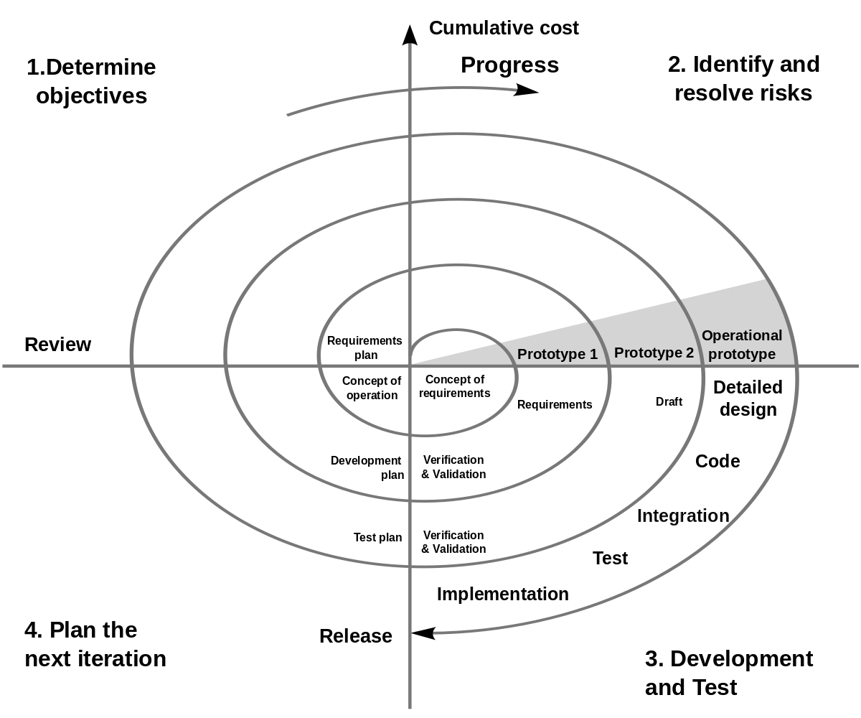

Fig – 1

1. **Determine Objectives**

 Each cycle in the spiral starts with the identification of purpose for that cycle, the various alternatives that are possible for achieving the targets, and the constraints that exist.

1. **Identify and resolve risks**

The next phase in the cycle is to calculate these various alternatives based on the goals and constraints. The focus of evaluation in this stage is located on the risk perception for the project.

1. **Development and test**

The next phase is to develop strategies that resolve uncertainties and risks. This process may include activities such as benchmarking, simulation, and prototyping.

1. **Plan the next iteration**

Finally, the next step is planned. The project is reviewed, and a choice made whether to continue with a further period of the spiral. If it is determined to keep, plans are drawn up for the next step of the project.

**Advantages of the Spiral Model**

* A high amount of risk analysis hence, avoidance of risk is enhanced.
* Strong approval and documentation control.
* Additional Functionality can be added at a later date.
* Software is produced early in the software life cycle.

**DESIGN**

**SYSTEM DESIGN**

It is a process of planning a new business system or replacing an existing system by defining its components or modules to satisfy the specific requirements. Before planning, you need to understand the old system thoroughly and determine how computers can best be used in order to operate efficiently.

System design focuses on how to accomplish the objective of the system.

**PERT CHART**

A PERT chart is a graphic representation of a project’s schedule, showing the sequence of tasks, which tasks can be performed simultaneously, and the critical path of tasks that must be completed on time in order for the project to meet its completion deadline. The chart can be constructed with a variety of attributes, such as the earliest and latest start dates for each task, earliest and latest finish dates for each task, and slack time between tasks. A PERT chart can document an entire project or a key phase of a project. The chart allows a team to avoid unrealistic timetables and schedule expectations, to help identify and shorten tasks that are bottlenecks, and to focus attention on most critical tasks.

Because it is primarily a project management tool, a PERT chart is most useful for planning and tracking entire projects or for scheduling and tracking the implementation phase of planning or improvement effort.

|  |  |
| --- | --- |
| Start | |
| 00 | 0 days |
| 08-04-2021 | 08-04-2021 |

|  |  |
| --- | --- |
| Requirement gathering | |
| 01 | 15 days |
| 08-04-2021 | 23-04-2021 |

|  |  |
| --- | --- |
| Requirement Analysis | |
| 02 | 12 days |
| 23-04-2021 | 05-05-2021 |

|  |  |
| --- | --- |
| System Analysis and Design | |
| 03 | 25 days |
| 05-05-2021 | 30-05-2021 |

|  |  |
| --- | --- |
| Database design | |
| 04 | 05 days |
| 30-05-2021 | 04-06-2021 |

|  |  |
| --- | --- |
| User Interface design | |
| 05 | 15 days |
| 04-06-2021 | 19-06-2021 |

|  |  |
| --- | --- |
| Coding | |
| 06 | 55 days |
| 19-06-2021 | 13-08-2021 |

|  |  |
| --- | --- |
| Testing and Implementation | |
| 07 | 10 days |
| 13-08-2021 | 23-08-2021 |

|  |  |
| --- | --- |
| Report | |
| 08 | 07 days |
| 23-08-2021 | 30-8-2021 |

Fig - 2

**GANTT CHART**

A Gantt chart is a popular tool in project management. It basically drills down activities that need to be done by a fixed time period. It is commonly used for tracking project schedules. It schedules the start and finishes dates of the terminal elements and summary elements of a project.

On the chart, tasks are shown on the vertical axis while they scheduled time-spend is laid out on the horizontal axis. Each task is represented by a bar that shows the time required for the project.

Gantt chart is a useful tool in planning and scheduling projects. It keeps the management updated as to when the project will get completed. It also keeps the management informed about any additional resources that are required and manage dependencies between tasks.

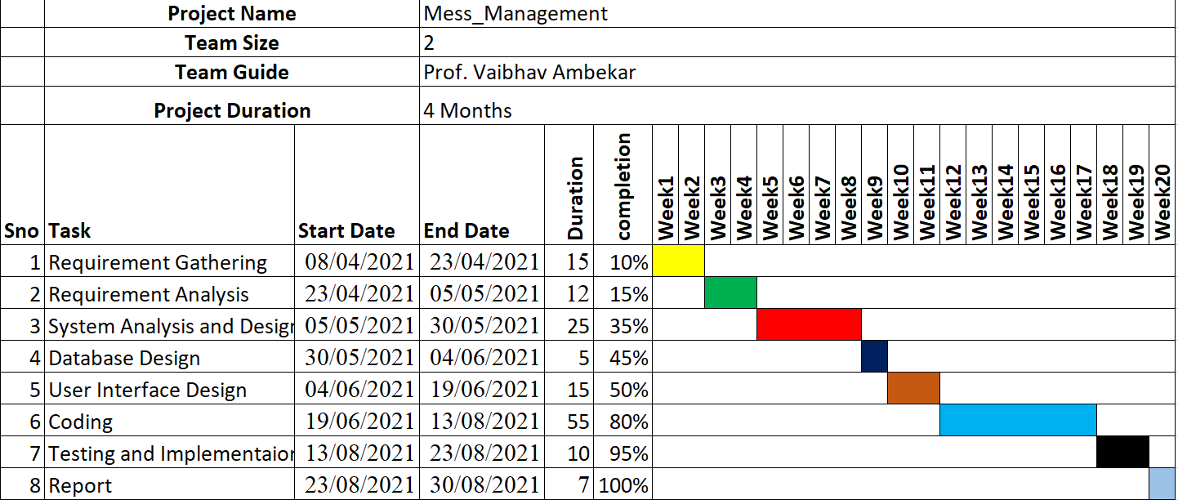

Fig – 3

Use case diagram: -

A use case diagram as its simplest is a representation of a user’s interaction with the system that shows the relationship between the user and the different use cases in which the user is involved. A use case diagram can identify the different use cases and will often be accompanied by other types of diagrams as well.

While a use case itself might drill into a lot of detail about every possibility, the use case diagram can help provide a higher-level view of the system. It has been said before that “Use Case diagrams are the blueprints for the system”. They provide the specified and graphical representation of what the system must actually do.

A use case diagram contains four components:

* The boundary, which defines the system of interest in relation to the world around it.
* The actors, usually individuals involved with the systems defined according to their roles.
* The use cases in which the specific roles are played by the actors within and around the system.
* The relationships between and among the actors and the use cases.

**Use Case Diagram: -**

Admin

User

Fig – 4

Activity diagram: -

The activity diagram is another important behavioural diagram in the UML diagram to describe the dynamic aspects of the system. The activity diagram is essentially an advanced version of the flow chart that modelling the flow from one activity to another activity.

Activity Diagrams describe how activities are coordinated to provide a service which can be at different levels of abstraction. Typically, an event needs to be achieved by some operations, particularly where the operation is intended to achieve a number of different things that require coordination, or how the events in a single-use case relate to one another, in particular, use cases where activities may overlap and require coordination. It is also suitable for modelling how a collection of use cases coordinates to represent business workflows

1. Identify candidate use cases, through the examination of business workflows
2. Identify pre- and post-conditions (the context) for use cases
3. Model in detail complex activities in a high-level activity Diagram.

Admin Login

Invalid Id & Password

Admin Registration

Check Id & Password

Login Successfully

User Level Permission

Logout

Fig – 5

E-R diagram: -

ER (Entity-Relationship) diagram is a popular high-level conceptual data model and its variations are frequently used for the conceptual design of the database design tools to employ its concepts. It is used in the design of conceptual schemas for database applications.

**Entities and attributes:**

The basic object that the ER model represents is an entity, which is a “thing” in the real world with an independent existence. An entity may be an object with a physical existence a particular person car or an employee or it may be an object with conceptual existence particular properties that describes it.

Admin

User

Accesses

Fig – 6

**IMPLEMENTATION**

**DATA FLOW DIAGRAMS**

**Data Flow Diagrams (DFD):**

A Data Flow Diagram is graphical aid for defining systems input, process, and outputs. It represents increasing information flow and function details.

A DFD shows the flow of data through a system. A system may be an organization, a manual procedure, a software system, a mechanical system, a hardware system, or any combinations of these. A DFD shows the movement of data through different processes in the system DFD’s are made of a number of symbols, which represent system components like process, data flow, and external entities.

1. **Process:**

The process shows that systems do each process can have one or more inputs or outputs. A process in DFD is represented as a hollow cylinder. And each process has a unique name and number.

1. **Data Store:**

A file or datastore is a repository of data. Each datastore is represented by an open-sided rectangle and each store and has a unique name. The symbol of the data store is.

1. **External Entities:**

External entities are outside the system but they either supply input into the system or use the system output. They may be an organization’s customer or others which system interacts. External entities, which supply data to the system, are sometimes called as ‘sinks’. These are represented by a rectangle in the DFD.

1. **Data Flow**

Data flow indicates the passage of data in the system, from where the data flows. It is indicated by an arrow which indicates the direction of flow. The arrow is labeled by the name of the data flow.

The flow of data in the system could be any one of the following:

* From a data store to a process.
* From source to process.
* From a process to a sink.

**Context Level DFD:**

User

Admin

Register And Login

Register And Login

Update

Fig – 7

**TOP Level DFD:**

ADMIN REGISTER DB

Admin

USER REGISTER DB

Users

ADMIN INFO

USER INFO

RECORDS DB

CONTROLS

MESSAGES

Fig – 8

Technologies used: -

* HTML 5 (Hyper Text Mark-up Language): -

HTML, which stands for hypertext mark-up language, is the mark-up language for web pages. A mark-up language is a set of mark-up tags, and HTML uses mark-up tags to describe web pages. HTML is the building block of all basic websites. It allows images and objects to be embedded and can be used to create interactive forms. It provides a means to create structured documents by denoting structural semantics for text such as headings, paragraphs, lists, links, quotes, and other items. It can embed scripts in languages such as JavaScript which affect the behaviour of HTML Webpages. HTML can also be used to include Cascading Style Sheets (CSS) to define the appearance and layout of text and other material.

HTML is written in the form of HTML elements consisting of “tags” surrounded biangular brackets (like <html>) within the web page content. The first tag in a pair is the start tag, the second tag is the end tag (they are also called opening tags and closing tags).

HTML Structure: -

<html>

<head>

<title>Page title</title>

</head>

<body>

<h1>This is a heading</h1>

<p>This is a paragraph. </p>

<p>This is another paragraph. </p>

</body>

</html>

* Cascading Style Sheet (CSS): -

Cascading Style Sheets is a style sheet language used for describing the presentation of a document written in a mark-up like HTML.CSS is a cornerstone technology of the World Wide Web, alongside HTML and JavaScript.

CSS is designed to enable the separation of presentation and content, including layout, colours, and fonts. This separation can improve content accessibility, provide more flexibility and control in the specification of presentation characteristics, enable multiple web pages to share formatting by specifying the relevant CSS in a separate .CSS file which reduces complexity and repetition in the structural content as well as enabling the .CSS file to be cached to improve the page load speed between the pages that share the file and its formatting.

Separation of formatting and content also makes it feasible to present the same mark-up page in different styles for different rendering methods, such as on-screen, in print, by voice (via speech-based browser or screen reader), and on Braille-based tactile devices. CSS also has rules for alternate formatting if the content is accessed on a mobile device.

The name cascading comes from the specified priority scheme to determine which style rule applies if more than one rule matches a particular element. This cascading priority scheme is predictable.

The CSS specifications are maintained by the World Wide Web Consortium (W3C). Internet media type (MIME type) text/CSS is registered for use with CSS by RFC 2318 (March 1998). The W3C operates a free CSS validation service for CSS documents.

* PHP: -

PHP is a general-purpose scripting language that is especially suited to web development. It was originally created by Danish-Canadian programmer Rasmus Lerdorf in 1994, the PHP reference implementation is now produced by The PHP Group. PHP originally stood for Personal Home Page, but it now stands for the recursive initialized PHP: Hypertext Pre-processor.PHP code is usually processed on a web server by a PHP interpreter implemented as a module, a daemon or as a Common Gateway Interface (CGI) executable. On a web server, the result of the interpreted and executed PHP code – which may be any type of data, such as generated HTML or binary image data – would form the whole or part of a HTTP response. Various web template systems, web content management systems, and web frameworks exist which can be employed to orchestrate or facilitate the generation of that response. Additionally, PHP can be used for many programming tasks outside of the web context, such as standalone graphical applications and robotic drone control.Arbitrary PHP code can also be interpreted and executed via command-line interface (CLI). The standard PHP interpreter, powered by the Zend Engine, is free software released under the PHP License. PHP has been widely ported and can be deployed on most web servers on almost every operating system and platform, free of charge.

* JavaScript: -

JavaScript is an object-oriented, client-side scripting language, which means the source code is processed by the client's web browser rather than on the web server. This means JavaScript functions can run after a webpage has loaded without communicating with the server. This means JavaScript functions can run after a webpage has loaded without communicating with the server. It is a text-based programming language meant to run as a part of a web-based application. JavaScript is one of the three pillars of web development- the other two being HTML and CSS. It was purposely designed to integrate into HTML. All major web browsers support JavaScript.

* MySQL Database: -

MySQL is an open-source relational database management system (RDBMS). Its name is combinations of “My”, the name of co-founder Michael Widenius's daughter, and "SQL", the abbreviation for Structured Query Language. A relational database organizes data into one or more data tables in which data types may be related to each other; these relations help structure the data. SQL is a language programmer use to create, modify and extract data from the relational database, as well as control user access to the database. In addition to relational databases and SQL, an RDBMS like MySQL works with an operating system to implement a relational database in a computer's storage system, manages users, allows for network access and facilitates testing database integrity and creation of backups.

* XAMPP: -

XAMPP is a free and open-source cross-platform web server solution stack package developed by Apache Friends, consisting mainly of the Apache HTTP Server, MariaDB database, and interpreters for scripts written in the PHP and Perl programming languages. Since most actual web server deployments use the same components as XAMPP, it makes transitioning from a local test server to a live server possible. XAMPP's ease of deployment means a WAMP or LAMP stack can be installed quickly and simply on an operating system by a developer, with the advantage that common add-in applications such as Word Press and Joomla! Can also be installed with similar ease using Bitnami.

**CODING**

Project Code:

<!DOCTYPE html>

<html>

    <head>

        <title>login</title>

        <meta charset="UTF-8">

        <meta http-equiv="X-UA-Compatible" content="IE=edge">

        <meta name="viewport" content="width=device-width,initial-scale=1.0">

        <link rel="stylesheet" type="text/css" href="login.css">

        <link rel="stylesheet" href="https://cdnjs.cloudflare.com/ajax/libs/font-awesome/4.7.0/css/font-awesome.min.css">

    </head>

    <body>

        <div class="container">

            <div class="card">

                    <div class="front">

                        <h1>LOGIN</h1>

                        <form action="login.php" method="POST">

                            <p>Email Id

                                <input type="email" name="Email" class="input-box" placeholder="Email" required></p>

                            <p>Password

                                <input type="password" name="Pass" id="pass1" class="input-box" placeholder="Password" required></p>

                            <!--<span class="show-hide">

                                <i class="fa fa-eye"></i></span>-->

                            <a href="main.html">

                            <button type="submit" name="submit" class="login-btn">LogIn</button>

                        </a>

                            <a href="forgot.html">Forgot  Password ?</a>

                        </form>

                        <a href="register.html">

                            <button type="submit" class="reg-btn">New User? Register Here</button></a>

            </div>

        </div>

    </body>

</html>

*{

    margin: 0;

    padding: 0;

}

.container{

    width: auto;

    height: 100vh;

    font-family: sans-serif;

    background: linear-gradient(blue,red);

    color: #fff;

    display: flex;

    align-items: center;

    justify-content: center;

}

.card{

    width: 350px;

    height: 500px;

    box-shadow: 0 0 40px 20px rgba(0, 0, 0,0.26);

    perspective: 1000px ;

    border-radius: 10%;

}

.inner-box{

    position: relative;

    width: 100%;

    height: 100%;

    transition: transform 1s;

    transform-style: preserve-3d;

}

.front{

    position: absolute;

    width: 100%;

    height: 100%;

    background-position: center;

    background-size: cover;

    background-image: linear-gradient(black,black),url(bg.jpg);

    padding: 55px;

    box-sizing: border-box;

    border-radius: 10%;

}

.card h1{

    font-weight: normal;

    font-size: 24px;

    text-align: center;

    margin-bottom: 20px;

    margin-top: 20px;

}

.input-box{

    width: 100%;

    background: transparent;

    border: 1px solid #fff;

    margin: 6px 0;

    height: 32px;

    border-radius: 20px;

    padding: 0 10px;

    box-sizing: border-box;

    outline: none;

    text-align: center;

    color: #fff;

}

input::placeholder{

    color: #fff;

    font-size: 12px;

}

/*.show-hide{

    position: absolute;

    color: #a6a6a6;

    right: 15px;

    top: 50%;

    transform: translateY(-50%);

}

.show-hide i{

    font-size: 19px;

    color: black;

    cursor: pointer;

    display: block;

}

.show-hide i.hide::before{

    content: '\f070';

}

input:valid ~ .show-hide i{

    display: block;

}*/

button{

    width: 100%;

    background: transparent;

    border: 1px solid #fff;

    margin: 35px 0 10px;

    height: 32px;

    font-size: 12px;

    border-radius: 20px;

    padding: 0 10px;

    box-sizing: border-box;

    outline: noun;

    color: #fff;

    cursor: pointer;

}

.reg-btn{

    position: relative;

}

.reg-btn::after{

    content: '\27a4';

    color: #333;

    line-height: 32px;

    font-size: 17px;

    height: 32px;

    width: 32px;

    border-radius: 50%;

    background: #fff;

    position: absolute;

    right: -1px;

    top: -1px;

}

.card .btn{

    margin-top: 90px;

}

.card a{

    color: #fff;

    display: block;

    text-align: center;

    font-size: 13px;

    margin-top: 8px;

}

.login-btn{

    position: relative;

}

.login-btn::after{

    content: '\27a4';

    color: #333;

    line-height: 32px;

    font-size: 17px;

    height: 32px;

    width: 32px;

    border-radius: 50%;

    background: #fff;

    position: absolute;

    right: -1px;

    top: -1px;

}

<?php

    //database connection

    $conn=mysqli_connect('localhost','root');

    mysqli_select_db($conn,'mess_management');

    if ($conn)

    {

        //echo "Connected";

        # code...

    }

    else

    {

        echo "Not Connected";

        # code...

    }

    if(isset($_POST['submit']))// accessing through submit btn

    {

        //assigning values

        $email=$_POST['Email'];

        $Pass=$_POST['Pass'];

        // query for fetching email and password

        $sql = "SELECT * FROM admin_register WHERE email='$email' and pass='$Pass' ";

        $result = mysqli_query($conn,$sql);

        if($result->num_rows > 0)// checking for email exist or not

        {

            $row = mysqli_fetch_assoc($result);

            ?>

            <script>

                //pop up message code for login

                alert("LogIn sucessfull");

                window.location.replace('main.html');

            </script>

            <?php

            #code...

        }

        else

        {

            ?>

            <script>

                //pop up message code

                alert("Email or Password is not correct");

                window.location.replace('login.html');

            </script>

            <?php

            #code...

        }

    }

?>

<html>

    <head>

        <title>registration Form</title>

        <meta charset="UTF-8">

    <meta http-equiv="X-UA-Compatible" content="IE=edge">

    <meta name="viewport" content="width=device-width,initial-scale=1.0">

        <link rel="stylesheet" type="text/css" href="register.css">

    </head>

    <body>

        <div class="container">

            <div class="card">

                <div class="card-back">

                    <form action="register.php" method="POST">

                    <h1>REGISTER</h1>

                        <p>First Name

                        <input type="text"  name="FName" class="input-box" placeholder="First Name" required></p>

                        <p>Last Name

                        <input type="text" name="LName" class="input-box" placeholder="Last Name" ></p>

                        <p>Password

                        <input type="password" name="Pass" id="pass1" class="input-box" placeholder="Passwoed" required></p>

                        <p>Confirm Password

                        <input type="password/text" name="ConPass" id="pass2" class="input-box" placeholder="Confirm Password" required></p>

                        <p>Email Id

                        <input type="email" name="Email" class="input-box" placeholder="Email" required></p>

                        <p>Contact_Number

                        <input type="tel" name="Phone" class="input-box" placeholder="Contact_Number"   required></p>

                        <a href="login.html">

                        <button type="submit" value="submit" name="submit" class="reg-btn">Validate</button></a>

                        </form>

                </div>

            </div>

        </div>

    </body>

</html>

*{

    margin: 0;

    padding: 0;

}

.container{

    width: auto;

    height: 100vh;

    font-family: sans-serif;

    background: linear-gradient(red,blue);

    color: #fff;

    display: flex;

    align-items: center;

    justify-content: center;

}

.card{

    width: 350px;

    height: 650px;

    box-shadow: 0 0 40px 20px rgba(0, 0, 0,0.26);

    perspective: 1000px ;

    border-radius: 5%;

}

.card-back{

    position: absolute;

    width: 100%;

    height: 100%;

    background-position: center;

    background-size: cover;

    background-image: linear-gradient(black,black),url(bg.jpg);

    padding: 55px;

    box-sizing: border-box;

    border-radius: 5%;

}

.card h1{

    font-weight: normal;

    font-size: 24px;

    text-align: center;

    margin-bottom: 20px;

    margin-top: 10px;

}

.input-box{

    width: 100%;

    background: transparent;

    border: 1px solid #fff;

    margin: 12px 0;

    height: 32px;

    border-radius: 20px;

    padding: 0 10px;

    box-sizing: border-box;

    outline: none;

    text-align: center;

    color: #fff;

}

button{

    width: 100%;

    background: transparent;

    border: 1px solid #fff;

    margin: 35px 0 10px;

    height: 32px;

    font-size: 12px;

    border-radius: 20px;

    padding: 0 10px;

    box-sizing: border-box;

    outline: noun;

    color: #fff;

    cursor: pointer;

}

.reg-btn{

    position: relative;

}

.reg-btn::after{

    content: '\27a4';

    color: #333;

    line-height: 32px;

    font-size: 17px;

    height: 32px;

    width: 32px;

    border-radius: 50%;

    background: #fff;

    position: absolute;

    right: -1px;

    top: -1px;

}

.card .btn{

    margin-top: 20px;

}

<?php

    //database connection

    $conn=mysqli_connect('localhost','root');

    mysqli_select_db($conn,'mess_management');

    if ($conn)

    {

        // echo "Connected";

        # code...

    }

    else

    {

        echo "Not Connected";

        # code...

    }

    if(isset($_POST['submit'])){// accessing through submit btn

        //assigning values

        $Fname=$_POST['FName'];

        $Lname=$_POST['LName'];

        $Pass=$_POST['Pass'];

        $Confirm=$_POST['ConPass'];

        $Email=$_POST['Email'];

        $Phone=$_POST['Phone'];

       // $token=bin2hex(random_bytes(15));

        // email verification

        $emailquery = "SELECT * FROM admin_register WHERE Email='$Email'";

        $query = mysqli_query($conn,$emailquery);

        $emailcount =  mysqli_num_rows($query);

        if ($emailcount>0) { //condition of email verification

            ?>

            <script>

                //pop up message code

                alert("email already exist");

                window.location.replace('register.html');

            </script>

            <?php

            # code...

        }

        else{

            if($Pass === $Confirm)// password condition

            {

                //insert query... adding details to database

                $q = "INSERT INTO `admin_register` VALUES(`Id`,'$Fname','$Lname','$Pass','$Email','$Phone','')";

                $query = mysqli_query($conn,$q);

                if(mysqli_query($conn, $query))

                {

                }

                ?>

                <script>

                    alert("Registered  Successfully");

                    window.location.replace('login.html');

                </script>

                <?php

                #code...

           }

            else

            { // wrong password code

                ?>

                <script>

                    alert("password does not matched ");

                    window.location.replace('register.html');

                </script>

                <?php

                #code...

            }

        }

    }

?> <!DOCTYPE html>

<html>

<head>

    <meta charset="UTF-8">

    <meta http-equiv="X-UA-Compatible" content="IE=edge">

    <meta name="viewport" content="width=device-width,initial-scale=1.0">

    <link rel="stylesheet" type="text/css" href="main.css">

    <link rel="stylesheet" href="https://cdnjs.cloudflare.com/ajax/libs/font-awesome/4.7.0/css/font-awesome.min.css">

    <title></title>

</head>

<body>

    <div class="menu-bar">

         <ul>

            <li ><a href="#"><i class="fa fa-home"></i> Home</a></li>

                <li><a href="#"><i class="fa fa-registered"></i> Registation</a>

                    <div class="sub-menu1">

                        <ul>

                            <li><a href="./register.html">Admin</a></li>

                            <li><a href="/Mess_management/User/user_register.html">User</a></li>

                        </ul>

                    </div>

                </li>

                 <li><a href="./QRcode.html"><i class="fa fa-qrcode"></i> QR Code</a></li>

                 <li><a href="./records.php" class="fa fa-users"></i> Account</a></li>

                 <li><a href="#"><i class="fa fa-rupee"></i> Payment</a></li>

                 <li><a href="./login.html"><i class="fa fa-sign-out"></i> Logout</a></li>

        </ul>

    </div>

    <div id="slider">

        <figure>

            <img src="./slider_photos/eidli.jpg" style="width:185px; height:250px;" class="photo">

            <img src="./slider_photos/edosa.jpg" style="width:185px; height:250px;" class="photo">

            <img src="./slider_photos/ejam.jpg" style="width:185px; height:250px;" class="photo">

            <img src="./slider_photos/ejamun.jpg" style="width:185px; height:250px;" class="photo">

            <img src="./slider_photos/echanna.jpg" style="width:185px; height:250px;" class="photo">

            <img src="./slider_photos/epulao.jpg" style="width:185px; height:250px;" class="photo">

            <img src="./slider_photos/eice.jpg" style="width:185px; height:250px;" class="photo">

            <img src="./slider_photos/etea.jpg" style="width:185px; height:250px;" class="photo">

        </figure>

    </div>

    <div style="background-color: black"><marquee style="color:white;" direction = "right", scrollamount="15"><i><b style="font-size:150%;text-shadow: 1px 1px blue;">WELCOME TO P & Z EATERY AND EATING HOUSE</b></i></marquee></div>

    <p class = "side">The <strong></strong><abbr title="P & Z  EATERY AND EATING HOUSE">PZEAE</abbr></strong> is runned by the Chef on Wheels. It is one of a kind catering service that offers high quality & cost effective service. Our prime focus is to provide healthy and delicious food for everyone, anytime, anywhere. We believe that food served with warmth and the right attitude will leave a lasting impression in the minds of people being served. Our priority is to maintain a standard operating procedure, uniformly practiced across various sites with high emphasis on following food safety protocols and compliance with all statutory norms.</p>

    <p class = "side">Our expertise in world cuisine and a dynamic delivery team comprising of specialized chefs and nutritionists, has been the cornerstone of our success in delivering high quality food services over the years. We also provide end to end catering solutions from equipment selection to kitchen set up and efficient operationalization. Most importantly any kind of harmful food additives are not used in food preparation.</p>

    <dl style="margin: 20px; padding: 10px">

        <dt style="font-size: 20px;"><b>NOTE :</b></dt>

        <dd style="font-size: 20px;"><strong>Membership</strong> is compulsory for getting services from our eatery and eating house. </dd>

    </dl>

    <dl style="margin: 20px; padding: 10px">

        <dt style="font-size: 20px;"><b> Registration Requirements :</b></dt>

        <dd style="font-size: 20px;"> 1) Resgistration will be strickly done by the staff members at desk.</dd>

        <dd style="font-size: 20px;"> 2) Only mess members are permitted to use mess facilities at the mess.</dd>

        <dd style="font-size: 20px;"> 3) Futher information will be given once after the registration is confirmed.</dd>

        <dd style="font-size: 20px;"> 4) The generally adhered timing of messes is as follows. However, there may be a slight variation in timings of different messes.</dd><br>

        <dd style="font-size: 20px;"> <b>Breakfast :</b><i> 08.00 am to 10.00 am</i></dd>

        <dd style="font-size: 20px;"> <b>Lunch :</b><i> 01.00 pm to 4.00 pm</i></dd>

        <dd style="font-size: 20px;"> <b>Dinner :</b><i> 08.00 pm to 11.00 pm</i></dd><br>

        <dd style="font-size: 20px;"> 5) Those who are going for vacation for more than five days are requested to fill the dates of absence in the leave register (deduction book) held in the mess, at least a day in advance. </dd>

        <dd style="font-size: 20px;"> 6) Deactivation of mess membership will be done only on the last date of every month. </dd>

    </dl><br>

    <dl style="margin: 20px; padding: 10px">

        <dt style="font-size: 20px;"><b> General Instructions :</b></dt>

        <dd style="font-size: 20px;"> 1) Mess is not responsible for any of your belongings.</dd>

        <dd style="font-size: 20px;"> 2) Do not keep used plates on table after having food.  They are to be left at the Plate Disposable area.</dd>

        <dd style="font-size: 20px;"> 3) Sharing of food is not allowed. Anyone doing the same will be penalized. </dd>

        <dd style="font-size: 20px;"> 4) Request all the members to follow the mess timing properly. </dd>

        <dd style="font-size: 20px;"> 5) Outside food is not allowed in our mess.</dd>

        <dd style="font-size: 20px;"> 6) Mess properties are not to be taken outside the mess premises.</dd>

        <dd style="font-size: 20px;"> 7) Leave and Cancellation will not be considered if the members do not make requisite entries in the registers held in the mess.</dd>

        <dd style="font-size: 20px;"> 8) Using power lines & internet is restricted.</dd>

        <dd style="font-size: 20px;"> 9) Non-members are not permitted to use the membership on behalf of an active member.</dd>

    </dl><br>

    <div style="background: black;color: white;font-size: 20px"> Connect us at :

        <a href="https://www.facebook.com/"><i class="fa fa-facebook-square" style="font-size: 20px;color:white"></i></a>

        <a href="https://accounts.google.com/signin/v2/challenge/pwd?sacu=1&passive=1209600&acui=0&flowName=GlifWebSignIn&flowEntry=ServiceLogin&cid=1&navigationDirection=forward&TL=AM3QAYbCzswCWucdgLHg8sMq3c572qRAnyvxzxqZFcjen2OGGIhtn6V27THfaru4"><i class="fa fa-google" style="font-size: 20px;color:white"></i></a>

        <a href="https://www.instagram.com/accounts/login/?hl=en"><i class="fa fa-instagram" style="font-size: 20px;color:white"></i></a>

        <a href="https://twitter.com/login"><i class="fa fa-twitter-square" style="font-size:20px;color:white"></i></a>

    </div>

    <div style="background: black;color: white;padding: 20px"><h4 style="text-align: center;"><i class="fa fa-copyright"></i> Copyright 2021-2022 by PZEAE.</h4><h4 style="text-align: center;"> All Rights Reserved.</h4></div>

</body>

</html>

<!doctype html>

<head>

  <style>

      /* CSS comes here */

    body

    {

      width: auto;

      height: auto;

      background-image: linear-gradient(blue,red);

      padding:183px;

      align-items: center;

      text-align: center;

    }

    input

    {

      padding:5px;

      background-color:transparent;

      border:none;

      border-bottom:solid 4px #8c52ff;

      width:250px;

      font-size:16px;

      color:white;

    }

    .qr-btn

    {

      background-color:black;

      padding:8px;

      color:white;

      cursor:pointer;

    }

  </style>

  <title>QR Code Generator</title>

  <meta charset="UTF-8">

  <meta http-equiv="X-UA-Compatible" content="IE=edge">

  <meta name="viewport" content="width=device-width,initial-scale=1.0">

</head>

<body>

  <h3>QR Code Generator</h3>

    <div><input id="qr-text" type="email" placeholder="Enter  Email" required/></div>

    <div><input id="qr-text2" type="date" placeholder="Enter date"/></div>

    <br/>

    <div>

      <button class="qr-btn" id="qr-btn" onclick="generateQRCode()">Create QR Code</button>

    </div>

    <br/>

    <p id="qr-result"></p>

    <canvas id="qr-code"></canvas>

    <script src="https://cdnjs.cloudflare.com/ajax/libs/qrious/4.0.2/qrious.min.js"></script>

    <script>  /* JS comes here */

    var qr;

    function generateQRCode()

    {

      (function()

      {

        qr = new QRious(

        {

          element: document.getElementById('qr-code'),

          size: 200,

          // value: 'https://studytonight.com'

        });

      })();

      var qrtext = document.getElementById("qr-text").value;

      var qrtext2 = document.getElementById("qr-text2").value;

      document.getElementById("qr-result").innerHTML = "QR code for " + qrtext  +"\n"+ qrtext2 + ":";

      qr.set(

      {

        foreground: 'black',

        size: 200,

        value: qrtext + qrtext2

      });

    }

    </script>

  </body>

</html>

<html>

<head>

<title>Displaying Records</title>

        <meta charset="utf-8">

        <meta name="viewport" content="width=device-width, initial-scale=1">

        <link rel="stylesheet" type="text/css" href="#">

<style>

#editbtn

{

    background-color:green;

    color:white;

    width:90px;

    font-size:14px;

    height:25px;

}

#dltbtn

{

    background-color:red;

    color:white;

    width:80px;

    font-size:14px;

    height:25px;

}

</style>

</head>

<body>

    <h2 align="center" style="width:40%;">Admin_Records</h2>

<h1><table   border="4" cellspacing="4" style="width:45%; float:left;">

<tr>

    <th>Id</th>

    <th>First_Name</th>

    <th>Last_Name</th>

    <th>Email</th>

    <th>Contact</th>

    <th colspan="2" align="center">Operations</th>

</tr>

</h1>

<?php

    //database connection

    $conn=mysqli_connect('localhost','root');

    mysqli_select_db($conn,'mess_management');

    if ($conn)

    {

         //echo "Connected";

        # code...

    }

    else

     {

    echo "no connected";

    #code....

     }

$query="SELECT * FROM admin_register";

$data=mysqli_query($conn,$query);

$total=mysqli_num_rows($data);

if($total!=0)

{

    while($result=mysqli_fetch_assoc($data))

    {

    echo"

    <tr>

       <td>".$result['Id']."</td>

        <td>".$result['FName']."</td>

        <td>".$result['LName']."</td>

        <td>".$result['Email']."</td>

        <td>".$result['Phone']."</td>

        <td><a href='update_Edit.php?Id=$result[Id] & FName=$result[FName] & LName=$result[LName] & Email=$result[Email] & Phone=$result[Phone] '><input type='submit' value='Edit/Update' id='editbtn'></td>

        <td><a href='delete.php?id=$result[Id]' onclick='return checkdelete() '><input type='submit' value='Delete' id='dltbtn'></td>

    </tr>";

    }

}

else

{

    echo "no data found";

}

?>

</table>

<script>

    function checkdelete()

    {

        return confirm ('Are you sure you want to Delete this Record');

    }

</script>

</body>

</html>

<!--user database-->

<html>

<head>

<title>Displaying Records</title>

        <meta charset="utf-8">

        <meta http-equiv="X-UA-Compatible" content="IE=edge">

        <meta name="viewport" content="width=device-width, initial-scale=1">

        <link rel="stylesheet" type="text/css" href="#">

<style>

#editbtn

{

    background-color:green;

    color:white;

    width:90px;

    font-size:14px;

    height:25px;

}

#dltbtn

{

    background-color:red;

    color:white;

    width:80px;

    font-size:14px;

    height:25px;

}

</style>

</head>

<body>

    <h2 align="center" style="width:40%; float:right;margin:-50px;margin-right:50px">User_Records</h2>

<h1><table   border="4" cellspacing="4" style="width:45%; float:right;margin-right:30px">

<tr>

    <th>Id</th>

    <th>First_Name</th>

    <th>Last_Name</th>

    <th>Email</th>

    <th>Contact</th>

    <th colspan="2" align="center">Operations</th>

</tr>

</h1>

<?php

    //database connection

    $conn=mysqli_connect('localhost','root');

    mysqli_select_db($conn,'mess_management');

    if ($conn)

    {

         //echo "Connected";

        # code...

    }

    else

     {

    echo "no connected";

    #code....

     }

$query="SELECT * FROM user_register";

$data=mysqli_query($conn,$query);

$total=mysqli_num_rows($data);

if($total!=0)

{

    while($result=mysqli_fetch_assoc($data))

    {

    echo"

    <tr>

       <td>".$result['Id']."</td>

        <td>".$result['FName']."</td>

        <td>".$result['LName']."</td>

        <td>".$result['Email']."</td>

        <td>".$result['Phone']."</td>

        <td><a href='User_update_Edit.php?id=$result[Id] & fn=$result[FName] & ln=$result[LName] & eml=$result[Email] & ph=$result[Phone] '><input type='submit' value='Edit/Update' id='editbtn'></td>

        <td><a href='User_delete.php?id=$result[Id]' onclick='return checkdelete() '><input type='submit' value='Delete' id='dltbtn'></td>

    </tr>";

    }

}

else

{

    echo "no data found";

}

?>

</table>

<script>

    function checkdelete()

    {

        return confirm ('Are you sure you want to Delete this Record');

    }

</script>

</body>

</html>

<html>

    <head>

        <title>Forgot_password</title>

        <meta charset="UTF-8">

        <meta http-equiv="X-UA-Compatible" content="IE=edge">

        <meta name="viewport" content="width=device-width,initial-scale=1.0">

        <link rel="stylesheet" type="text/css" href="forgot.css">

    </head>

    <body>

        <form action="forgot.php" method="POST">

            <div class="container">

                <div class="card">

                    <div class="front" >

                        <h1>Reset Password</h1>

                        <p>Email Id

                        <input type="email" name="Email" class="input-box" placeholder="Enter Email Address " required></p>

                        <a href="#">

                        <button type="submit" value="submit" name="submit" class="reg-btn">Send Password Reset Link </button></a>

                    </div>

                </div>

            </div>

        </form>

    </body>

</html>

*{

    padding: 0;

    margin: 0;

    font-family: sans-serif;

}

body{

    width: 100%;

    height: 100%;

    background: linear-gradient(red,blue);

    color: #fff;

    display: flex;

    align-items: center;

    justify-content: center;

}

.card{

    width: 350px;

    height: 350px;

    box-shadow: 0 0 40px 20px rgba(0, 10, 07, 0.26);

    perspective: 1000px ;

    border-radius: 10%;

}

.front{

    position: absolute;

    width: 100%;

    height: 100%;

    background-position: center;

    background-size: cover;

    background-image: linear-gradient(black,black),url(bg.jpg);

    padding: 55px;

    box-sizing: border-box;

    border-radius: 10%;

}

.card h1{

    font-weight: normal;

    font-size: 24px;

    text-align: center;

    margin-bottom: 20px;

    margin-top: 20px;

}

.input-box{

    width: 100%;

    background: transparent;

    border: 1px solid #fff;

    margin: 12px 0;

    height: 32px;

    border-radius: 20px;

    padding: 0 10px;

    box-sizing: border-box;

    outline: none;

    text-align: center;

    color: #fff;

}

button{

    width: 100%;

    background: transparent;

    border: 1px solid #fff;

    margin: 35px 0 10px;

    height: 32px;

    font-size: 14px;

    border-radius: 20px;

    padding: 0 10px;

    box-sizing: border-box;

    outline: noun;

    color: #fff;

    cursor: pointer;

}

.card a{

    color: #fff;

    display: block;

    text-align: center;

    font-size: 13px;

    margin-top: 8px;

}

.reg-btn{

    position: relative;

}

.reg-btn::after{

    content: '\27a4';

    color: #333;

    line-height: 32px;

    font-size: 17px;

    height: 32px;

    width: 32px;

    border-radius: 50%;

    background: #fff;

    position: absolute;

    right: -1px;

    top: -1px;

}

<?php

use PHPMailer\PHPMailer\PHPMailer;  //php mailer

use PHPMailer\PHPMailer\SMTP;

use PHPMailer\PHPMailer\Exception;

require 'PHPMailer/src/Exception.php';

require 'PHPMailer/src/PHPMailer.php';

require 'PHPMailer/src/SMTP.php';

//database connection

$conn=mysqli_connect('localhost','root');

mysqli_select_db($conn,'mess_management');

if ($conn)

{

  echo "Connected";

  # code...

}

else

{

  echo "Not Connected";

  # code...

}

function send_password_reset($name,$lname,$email,$token)

{

  //Server settings

   $mail=new PHPMailer(true);

  $mail->isSMTP();                                            //Send using SMTP

  $mail->Host       = 'smtp.gmail.com';                       //Set the SMTP server to send through

   $mail->SMTPAuth   = true;                                   //Enable SMTP authentication

  $mail->Username   = 'PandZEatery@gmail.com';             //SMTP username

  $mail->Password   = 'Arjun&Ajju98@Eatery';                           //SMTP password

  $mail->SMTPSecure = 'tls';

  $mail->Port       = 587;

  //Recipients

  $mail->setFrom('PandZEatery@gmail.com');

  $mail->addAddress($email);                     //recipient through database

  /* //Attachments

  $mail->addAttachment('/var/tmp/file.tar.gz');         //Add attachments

  $mail->addAttachment('/tmp/image.jpg', 'new.jpg');    //Optional name

  */

  //Content

  $url="http://localhost/Mess_Management/Admin/reset.php?token=$token & email=$email ";

  $mail->isHTML(true);                                  //Set email format to HTML

  $mail->Subject = "Reset Password Notification";

  $mail->Body    = "<h1>You requested to reset password..</h1>

  <h2>Dear  $name  $lname </h2>

  <h3>

  <pre>

  A request has been made to reset your password. If you made this request, please <a href='$url'>CLICK HERE</a> to complete your process.<br>

  If you did not request to reset your password, please ignore this message.

  Regards

  P & Z Eatery Support Team

  </pre></h3>";

  $mail->AltBody = 'This is the body in plain text for non-HTML mail clients';

  $mail->send();

}

if(isset($_POST['submit']))  // accessing through submit btn

{

  $email=$_POST['Email'];   //assigning values

  $token=bin2hex(random_bytes(15));

  $query="SELECT * from admin_register where email='$email'  ";

  $result=mysqli_query($conn,$query);

 if(mysqli_num_rows($result)> 0)

 {

  $row=mysqli_fetch_array($result);

   $name=$row['FName'];

   $lname=$row['LName'];

  $email=$row['Email'];

  $update_token="UPDATE admin_register SET Token='$token' WHERE Email='$email'";

  $update_token_run=mysqli_query($conn,$update_token);

  if($update_token_run)

  {

    send_password_reset($name,$lname,$email,$token);

    ?>

    <script>

      //pop up message code for login

      alert("Email sent sucessful");

      window.location.replace('login.html');

    </script>

    <?php

    #code...

  }

  else

  {

    ?>

    <script>

      //pop up message code

      alert("something went wrong");

      window.location.replace('forgot.html');

    </script>

    <?php

    #code...

  }

 }

 else

 {

  ?>

  <script>

    //pop up message code

    alert("Email  not correct");

    window.location.replace('forgot.html');

  </script>

  <?php

  #code...

 }

<html>

<head>

    <title>User_HomePage</title>

    <meta charset="utf-8">

    <meta http-equiv="X-UA-Comatible" content="IE=edge">

    <link rel="stylesheet" type="text/css" href="User_HomePage.css">

    <link rel="stylesheet" type="text/css" href="User_HomePage2.css">

    <link rel="stylesheet" href="https://cdnjs.cloudflare.com/ajax/libs/font-awesome/4.7.0/css/font-awesome.min.css">

</head>

<meta name="viewport" content="width=device-width, initial-scale=1">

<body>

<div class="menu-bar">

<ul>

    <li><a href="./User_Homepage.html" style="font-size:15px;"><i class="fa fa-home"></i> Home</a></li>

    <li><a href="#" style="font-size:15px;"><i class="fa fa-newspaper-o"></i> Menu</a>

        <div class="sub-menu-1" style="position: absolute; z-index: 1;border-radius: 15%">

            <ul>

                <li><a href="./Menu_Monday.html">Monday</a></li>

                <li><a href="./Menu_Tuesday.html">Tuesday</a></li>

                <li><a href="./Menu_Wednesday.html">Wednesday</a></li>

                <li><a href="./Menu_Thursday.html">Thursday</a></li>

                <li><a href="./Menu_Friday.html">Frinday</a></li>

                <li><a href="./Menu_Saturday.html">Saturday</a></li>

            </ul>

        </div>

    </li>

    <li><a href="./User_Services.html" style="font-size:15px;"><i class="fa fa-shopping-bag"></i> Services</a></li>

    <li><a href="./package.html"><i class="fa fa-rupee" style="font-size:15px;"></i> Package</a></li>

    <li><a href="./User_AboutUs.html" style="font-size:15px;"><i class="fa fa-user-circle"></i> About Us</a></li>

    <li><a href="./User_ContactUs.html" style="font-size:15px;"><i class="fa fa-phone"></i> Contact Us</a></li>

    <li><a href="" style="font-size:15px;">More <i class="fa fa-angle-double-down"></i></a>

        <div class="sub-menu-1" style="position: absolute; z-index: 1;border-radius: 15%">

            <ul>

                <li><a href="./qr-code-scanner/index.html">Scan</a></li>

                <li><a href="/mess_management/User/User_login.html">Log-Out</a></li>

            </ul>

        </div>

    </li>

</ul>

</div>

<br><br>

<div id="slider">

    <figure>

        <img src="./Breakfast/emong.jpg" style="width:185px; height:250px;" class="photo">

        <img src="./Breakfast/echanna.jpg" style="width:185px; height:250px;" class="photo">

        <img src="./Breakfast/ejamun.jpg" style="width:185px; height:250px;" class="photo">

        <img src="./Breakfast/evegb.jpg" style="width:185px; height:250px;" class="photo">

        <img src="./Breakfast/ejam.jpg" style="width:185px; height:250px;" class="photo">

        <img src="./Breakfast/esalad.jfif" style="width:185px; height:250px;" class="photo">

        <img src="./Breakfast/epaneers.jpg" style="width:185px; height:250px;" class="photo">

        <img src="./Breakfast/poha2.jpg" style="width:185px; height:250px;" class="photo">

    </figure>

</div>

<div style="background-color: black"><marquee style="color:white;" direction = "right", scrollamount="15"><i><b style="font-size:150%;text-shadow: 1px 1px blue;">WELCOME TO P & Z EATERY AND EATING HOUSE</b></i></marquee></div>

<p class = "side">The <strong></strong><abbr title="P & Z  EATERY AND EATING HOUSE">PZEAE</abbr></strong> is runned by the Chef on Wheels. It is one of a kind catering service that offers high quality & cost effective service. Our prime focus is to provide healthy and delicious food for everyone, anytime, anywhere. We believe that food served with warmth and the right attitude will leave a lasting impression in the minds of people being served. Our priority is to maintain a standard operating procedure, uniformly practiced across various sites with high emphasis on following food safety protocols and compliance with all statutory norms.</p>

<p class = "side">Our expertise in world cuisine and a dynamic delivery team comprising of specialized chefs and nutritionists, has been the cornerstone of our success in delivering high quality food services over the years. We also provide end to end catering solutions from equipment selection to kitchen set up and efficient operationalization. Most importantly any kind of harmful food additives are not used in food preparation.</p>

<dl style="margin: 20px; padding: 10px">

    <dt style="font-size: 20px;"><b>NOTE :</b></dt>

    <dd style="font-size: 20px;"><strong>Membership</strong> is compulsory for getting services from our eatery and eating house. </dd>

</dl>

<dl style="margin: 20px; padding: 10px">

    <dt style="font-size: 20px;"><b> Registration Requirements :</b></dt>

    <dd style="font-size: 20px;"> 1) Resgistration will be strickly done by the staff members at desk.</dd>

    <dd style="font-size: 20px;"> 2) Only mess members are permitted to use mess facilities at the mess.</dd>

    <dd style="font-size: 20px;"> 3) Futher information will be given once after the registration is confirmed.</dd>

    <dd style="font-size: 20px;"> 4) The generally adhered timing of messes is as follows. However, there may be a slight variation in timings of different messes.</dd><br>

    <dd style="font-size: 20px;"> <b>Breakfast :</b><i> 08.00 am to 10.00 am</i></dd>

    <dd style="font-size: 20px;"> <b>Lunch :</b><i> 01.00 pm to 4.00 pm</i></dd>

    <dd style="font-size: 20px;"> <b>Dinner :</b><i> 08.00 pm to 11.00 pm</i></dd><br>

    <dd style="font-size: 20px;"> 5) Those who are going for vacation for more than five days are requested to fill the dates of absence in the leave register (deduction book) held in the mess, at least a day in advance. </dd>

    <dd style="font-size: 20px;"> 6) Deactivation of mess membership will be done only on the last date of every month. </dd>

</dl><br>

<dl style="margin: 20px; padding: 10px">

    <dt style="font-size: 20px;"><b> General Instructions :</b></dt>

    <dd style="font-size: 20px;"> 1) Mess is not responsible for any of your belongings.</dd>

    <dd style="font-size: 20px;"> 2) Do not keep used plates on table after having food.  They are to be left at the Plate Disposable area.</dd>

    <dd style="font-size: 20px;"> 3) Sharing of food is not allowed. Anyone doing the same will be penalized. </dd>

    <dd style="font-size: 20px;"> 4) Request all the members to follow the mess timing properly. </dd>

    <dd style="font-size: 20px;"> 5) Outside food is not allowed in our mess.</dd>

    <dd style="font-size: 20px;"> 6) Mess properties are not to be taken outside the mess premises.</dd>

    <dd style="font-size: 20px;"> 7) Leave and Cancellation will not be considered if the members do not make requisite entries in the registers held in the mess.</dd>

    <dd style="font-size: 20px;"> 8) Using power lines & internet is restricted.</dd>

    <dd style="font-size: 20px;"> 9) Non-members are not permitted to use the membership on behalf of an active member.</dd>

</dl><br>

<div style="background: black;color: white;font-size: 20px"> Connect us at :

    <a href="https://www.facebook.com/"><i class="fa fa-facebook-square" style="font-size: 20px;color:white"></i></a>

    <a href="https://accounts.google.com/signin/v2/challenge/pwd?sacu=1&passive=1209600&acui=0&flowName=GlifWebSignIn&flowEntry=ServiceLogin&cid=1&navigationDirection=forward&TL=AM3QAYbCzswCWucdgLHg8sMq3c572qRAnyvxzxqZFcjen2OGGIhtn6V27THfaru4"><i class="fa fa-google" style="font-size: 20px;color:white"></i></a>

    <a href="https://www.instagram.com/accounts/login/?hl=en"><i class="fa fa-instagram" style="font-size: 20px;color:white"></i></a>

    <a href="https://twitter.com/login"><i class="fa fa-twitter-square" style="font-size:20px;color:white"></i></a>

</div>

<div style="background: black;color: white;padding: 20px"><h4 style="text-align: center;"><i class="fa fa-copyright"></i> Copyright 2021-2022 by PZEAE.</h4><h4 style="text-align: center;"> All Rights Reserved.</h4></div>

</body>

</html>

@keyframes slideShow {

    0%{left: 0px;}

    15%{left: 30%}

    30%{left: 50%;}

    45%{left: 70%;}

    60%{left: 90%;}

    75%{right: 70%;}

    85%{right: 50%;}

    95%{right: 30%;}

    100%{right: 0%;}

}

@keyframes slideShow1{

    0%{left: 0px;background-color: rgba(148, 0, 211,0.4)}

    15%{left: 30%;background-color: rgba(75, 0, 130,0.4)}

    30%{left: 50%;background-color: rgba(0, 0, 255,0.4)}

    45%{left: 70%;background-color: rgba(0, 255, 0,0.4)}

    60%{left: 90%;background-color: rgba(255, 255, 0,0.4)}

    75%{right: 70%;background-color: rgba(255, 127, 0,0.4)}

    85%{right: 50%;background-color: rgba(255, 0 , 0,0.4)}

    95%{right: 30%;background-color: rgba(0, 255, 0,0.4,0.4)}

    100%{right: 0%;background-color: rgba(255, 127, 0,0.4,0.4)}

}

#slider{

    overflow: hidden;

}

#slider figure img{

    width: 167px;

    float: right;

}

#slider figure{

    position: relative;

    width: auto;

    margin: 0;

    left: 0;

    font-size: 0;

    float: left;

    animation: 20s slideShow infinite;

}

#slider

{

    animation: 20s slideShow1 infinite;

}

.photo

{

    border : 2px solid black;

}

*

{

    padding: 0;

    margin: 0;

    box-sizing: border-box;

}

body

{

    background: rgba(100,100,100,0.4);

    background-size: cover;

    background-position: center;

    width: 100%;

    height: auto;

}

.menu-bar

{

    background: rgb(0,100,0);

    text-align:center;

}

.menu-bar ul

{

    display: inline-flex;

    list-style: none;

    color: white;

}

.menu-bar ul li

{

    width: 200px;

    margin: 5px;

    padding: 15px;

}

.menu-bar ul li a

{

    text-decoration: none;

    color: white;

}

.menu-bar ul li a:hover

{

    text-decoration: none;

    color: yellow;

}

.menu-bar ul li:hover

{

    border-radius: 5px;

    background: green;

    text-decoration: underline;

    text-shadow: 1px 1px black;

}

.side

{

    font-size: 15px;

    margin: 20px;

    padding : 10px;

    font-family: Arial, Helvetica, sans-serif;

}

.sub-menu-1

{

    display: none;

}

.menu-bar ul li:hover .sub-menu-1

{

    display: block;

    position: absolute;

    background :rgba(0,100,0,0.9);

    margin-top: 10px;

    margin-left: -15px;

}

.menu-bar ul li:hover .sub-menu-1 ul{

    display: block;

    margin:5px;

}

.menu-bar ul li:hover .sub-menu-1 ul li

{

    width: 150px;

    padding: 5px;

    border-bottom: 1px dotted #fff;

}

.menu-bar ul li:hover .sub-menu-1 ul li:last-child

{

    border-bottom: none;

}

<html>

<head>

    <title>User_HomePage</title>

    <link rel="stylesheet" type="text/css" href="User_HomePage.css">

    <link rel="stylesheet" href="https://cdnjs.cloudflare.com/ajax/libs/font-awesome/4.7.0/css/font-awesome.min.css">

</head>

<meta name="viewport" content="width=device-width, initial-scale=1">

<body>

<div class="menu-bar">

<ul>

    <li><a href="User_Homepage.html" style="font-size:15px;"><i class="fa fa-home"></i> Home</a></li>

    <li><a href="" style="font-size:15px;"><i class="fa fa-newspaper-o"></i> Menu</a>

        <div class="sub-menu-1" style="position: absolute; z-index: 1;border-radius: 15%">

            <ul>

                <li><a href="Menu_Monday.html">Monday</a></li>

                <li><a href="Menu_Tuesday.html">Tuesday</a></li>

                <li><a href="Menu_Wednesday.html">Wednesday</a></li>

                <li><a href="Menu_Thursday.html">Thursday</a></li>

                <li><a href="/Menu_Friday.html">Frinday</a></li>

                <li><a href="Menu_Saturday.html">Saturday</a></li>

            </ul>

        </div>

    </li>

    <li><a href="User_Services.html" style="font-size:15px;"><i class="fa fa-shopping-bag"></i> Services</a></li>

    <li><a href="./package.html"><i class="fa fa-rupee" style="font-size:15px;"></i> Package</a></li>

    <li><a href="User_AboutUs.html" style="font-size:15px;"><i class="fa fa-user-circle"></i> About Us</a></li>

    <li><a href="User_ContactUs.html" style="font-size:15px;"><i class="fa fa-phone"></i> Contact Us</a></li>

    <li><a href="" style="font-size:15px;padding:5px">More <i class="fa fa-angle-double-down"></i></a>

        <div class="sub-menu-1" style="position: absolute; z-index: 1;border-radius: 15%">

            <ul>

                <li><a href="./qr-code-scanner/index.html">Scan</a></li>

                <li><a href="/mess_management/User/User_login.html">Log-Out</a></li>

            </ul>

        </div>

    </li>

</ul>

</div>

<br><br>

<marquee style="color:white;background-color: black" direction = "right", scrollamount="15"><i><b style="font-size:150%;text-shadow: 1px 1px blue">WELCOME TO P & Z EATERY AND EATING HOUSE</b></i></marquee><br><br>

<div><h1 style="margin: 20px;padding: 10px; text-align: center;"><b>Hello!! Customers..</b></h1></div>

<p style="margin: 20px;padding: 10px;font-size: 25px"> For any queries regarding the mess and its services please contact the people at desk.</p><p style="margin: 20px;padding: 10px;font-size: 25px">Timing only from 9.00 am to 9.00 pm</p>

<p style="margin: 20px;font-size: 25px"><b>You can contact to :</b></p>

<ul style="margin: 20px;font-size: 20px;list-style: none">

    <li> Malgouda Patil  - 91+ 1236547890</li>

    <li> Ajay Zad        - 91+ 9874563210</li>

</ul>

<hr style="color:white;">

<br>

<p style="margin: 20px;font-size: 25px"><b>You can also reach us up by mailing to these concerned ID's. Mentioned below (ONLY FOR QUERIES)</b></p>

<ul style="margin: 20px;font-size: 20px;list-style: none">

    <li>Malgouda Patil  - <a href="mailto:pandzeatery@gmail.com">pandzeatery@gmail.com</a></li>

    <li>Ajay Zad  - <a href="mailto:pandzeatery@gmail.com">pandzeatery@gmail.com</a></li>

</ul><br><br>

<div style="background: black;color: white;font-size: 20px"> Connect us at :

    <a href="https://www.facebook.com/"><i class="fa fa-facebook-square" style="font-size: 20px;color:white"></i></a>

    <a href="https://accounts.google.com/signin/v2/challenge/pwd?sacu=1&passive=1209600&acui=0&flowName=GlifWebSignIn&flowEntry=ServiceLogin&cid=1&navigationDirection=forward&TL=AM3QAYbCzswCWucdgLHg8sMq3c572qRAnyvxzxqZFcjen2OGGIhtn6V27THfaru4"><i class="fa fa-google" style="font-size: 20px;color:white"></i></a>

    <a href="https://www.instagram.com/accounts/login/?hl=en"><i class="fa fa-instagram" style="font-size: 20px;color:white"></i></a>

    <a href="https://twitter.com/login"><i class="fa fa-twitter-square" style="font-size:20px;color:white"></i></a>

</div>

<div style="background: black;color: white;padding: 20px"><h4 style="text-align: center;"><i class="fa fa-copyright"></i> Copyright 2021-2022 by PZEAE.</h4><h4 style="text-align: center;"> All Rights Reserved.</h4></div>

</body>

</html>

<html>

<head>

  <title>User_HomePage</title>

  <meta charset="utf-8">

  <meta http-equiv="X-UA-Comatible" content="IE=edge">

  <link rel="stylesheet" type="text/css" href="User_HomePage.css">

  <link rel="stylesheet" type="text/css" href="User_HomePage2.css">

  <link rel="stylesheet" href="https://cdnjs.cloudflare.com/ajax/libs/font-awesome/4.7.0/css/font-awesome.min.css">

<style>

  * {

  box-sizing: border-box;

}

body {

  font-family: Arial;

  font-size: 17px;

}

.container {

  position: absolute;

  max-width: 170px;

}

.container .content {

  position: absolute;

  bottom: 0;

  background: rgb(0, 0, 0);

  background: rgba(0, 0, 0, 0.5);

  width: 118%;

  padding: 20px;

}

.overlay {

  position: absolute;

  top: 0;

  bottom: 0;

  left: 0;

  right: 0;

  height: 100%;

  width: 118%;

  opacity: 0;

  transition: .5s ease;

  background-color: rgba(0,0,0,0.7);

}

.container:hover .overlay {

  opacity: 1;

}

.text {

  color: white;

  font-size: 20px;

  position: absolute;

  top: 50%;

  left: 50%;

  -webkit-transform: translate(-50%, -50%);

  -ms-transform: translate(-50%, -50%);

  transform: translate(-50%, -50%);

  text-align: center;

}

@keyframes shake{

  0% { transform: translate(1px, 1px) rotate(0deg); }

  10% { transform: translate(-1px, -2px) rotate(-1deg); }

  20% { transform: translate(-3px, 0px) rotate(1deg); }

  30% { transform: translate(3px, 2px) rotate(0deg); }

  40% { transform: translate(1px, -1px) rotate(1deg); }

  50% { transform: translate(-1px, 2px) rotate(-1deg); }

  60% { transform: translate(-3px, 1px) rotate(0deg); }

  70% { transform: translate(3px, 1px) rotate(-1deg); }

  80% { transform: translate(-1px, -1px) rotate(1deg); }

  90% { transform: translate(1px, 2px) rotate(0deg); }

  100% { transform: translate(1px, -2px) rotate(-1deg); }

}

.container:hover {

  animation: shake 0.5s;

  animation-iteration-count: infinite;

}

</style>

</head>

<meta name="viewport" content="width=device-width, initial-scale=1">

<body>

<div class="menu-bar">

<ul>

  <li><a href="./User_Homepage.html" style="font-size:15px;"><i class="fa fa-home"></i> Home</a></li>

  <li><a href="" style="font-size:15px;"><i class="fa fa-newspaper-o"></i> Menu</a>

    <div class="sub-menu-1" style="position: absolute; z-index: 1;border-radius: 15%">

      <ul>

        <li><a href="./Menu_Monday.html">Monday</a></li>

        <li><a href="./Menu_Tuesday.html">Tuesday</a></li>

        <li><a href="./Menu_Wednesday.html">Wednesday</a></li>

        <li><a href="./Menu_Thursday.html">Thursday</a></li>

        <li><a href="./Menu_Friday.html">Frinday</a></li>

        <li><a href="./Menu_Saturday.html">Saturday</a></li>

      </ul>

    </div>

  </li>

  <li><a href="User_Services.html" style="font-size:15px;"><i class="fa fa-shopping-bag"></i> Services</a></li>

  <li><a href="package.html"><i class="fa fa-rupee" style="font-size:15px;"></i> Package</a></li>

  <li><a href="User_AboutUs.html" style="font-size:15px;"><i class="fa fa-user-circle"></i> About Us</a></li>

  <li><a href="User_ContactUs.html" style="font-size:15px;"><i class="fa fa-phone"></i> Contact Us</a></li>

  <li><a href="" style="font-size:15px;padding:5px">More <i class="fa fa-angle-double-down"></i></a>

    <div class="sub-menu-1" style="position: absolute; z-index: 1;border-radius: 15%">

      <ul>

        <li><a href="./qr-code-scanner/index.html">Scan</a></li>

        <li><a href="/mess_management/User/User_login.html">Log-Out</a></li>

      </ul>

    </div>

  </li>

</ul>

</div>

<br><br>

<marquee style="color:white;background-color: black" direction = "right", scrollamount="15"><i><b style="font-size:150%;text-shadow: 1px 1px blue">WELCOME TO P & Z EATERY AND EATING HOUSE</b></i></marquee>

<div>

  <div class="container" style="margin-left:60px;margin-top: 40px">

  <img src="./Breakfast/" style="width:200px; height:250px; border: 15px solid yellow;">

  <div class="content" style="text-align:center;">

    <h4 style="text-align:center;color:white">GOLD</h4>

  </div>

  <div class="overlay">

    <div class="text">PACKAGE</div>

  </div>

</div>

</div>

<div style="margin-left: 350px;margin-top: 60px;background-color: yellow;padding: 30px;margin-right: 150px;">

  <dl>

  <dt style="font-size: 20px;"><b><big>Golden Package </big></b></dt>

  <dd style="font-size: 20px;"> Rate : Rs.6000/- for per 3 months.</dd>

  <dd style="font-size: 20px;"> Rates are fixed. (No Discount available) </dd>

</dl>

</div>

</br></br></br></br></br></br></br></br></br><br><hr></br></br></br>

<div>

  <div class="container" style="margin-left:60px;margin-top: 40px">

  <img src="./Breakfast/" style="width:200px; height:250px; border: 15px solid #D3D3D3;">

  <div class="content" style="text-align:center;">

    <h4 style="text-align:center;color:white">SILVER</h4>

  </div>

  <div class="overlay">

    <div class="text">PACKAGE</div>

  </div>

</div>

</div>

<div style="margin-left: 350px;margin-top: 60px;background-color: #D3D3D3;padding: 30px;margin-right: 150px;">

  <dl>

  <dt style="font-size: 20px;"><b><big>Silver Package </big></b></dt>

  <dd style="font-size: 20px;"> Rate : Rs.4500/- for 2 months.</dd>

  <dd style="font-size: 20px;"> Rates are fixed. (No Discount available) </dd></dl>

</div>

</br></br></br></br></br></br></br></br></br><br><hr></br></br></br>

<div>

  <div class="container" style="margin-left:60px;margin-top: 40px">

  <img src="./Breakfast/" style="width:200px; height:250px; border: 15px solid #b08d57;">

  <div class="content" style="text-align:center;">

    <h4 style="text-align:center;color:white">BRONZE</h4>

  </div>

  <div class="overlay">

    <div class="text">PACKAGE</div>

  </div>

</div>

</div>

<div style="margin-left: 350px;margin-top: 60px;background-color: #b08d57;padding: 30px;margin-right: 150px;">

  <dl>

  <dt style="font-size: 20px;"><b><big>Bronze Package </big></b></dt>

  <dd style="font-size: 20px;"> Rate : Rs.2500/- for 1 month.</dd>

  <dd style="font-size: 20px;"> Rates are fixed. (No Discount available) </dd>

</dl>

</div>

</br></br></br></br></br></br></br></br></br><br>

<div style="background-color:rgba(0,0,0,0.7);color: white"><dl style="margin: 20px; padding: 10px"><br>

  <dt style="font-size: 20px;"><b> Note : </b></dt>

  <br>

  <dd style="font-size: 20px;"><i>We request our registered customers to please re-new your package validity before it gets expired. (To get access to our services) </i></dd></br>

  <dd style="font-size: 20px;"><i> We request the customers to pay the bill amount completely. No credit will be allowed. </i></dd>

</dl></div>

<div style="background: black;color: white;font-size: 20px"> Connect us at :

  <a href="https://www.facebook.com/"><i class="fa fa-facebook-square" style="font-size: 20px;color:white"></i></a>

  <a href="https://accounts.google.com/signin/v2/challenge/pwd?sacu=1&passive=1209600&acui=0&flowName=GlifWebSignIn&flowEntry=ServiceLogin&cid=1&navigationDirection=forward&TL=AM3QAYbCzswCWucdgLHg8sMq3c572qRAnyvxzxqZFcjen2OGGIhtn6V27THfaru4"><i class="fa fa-google" style="font-size: 20px;color:white"></i></a>

  <a href="https://www.instagram.com/accounts/login/?hl=en"><i class="fa fa-instagram" style="font-size: 20px;color:white"></i></a>

  <a href="https://twitter.com/login"><i class="fa fa-twitter-square" style="font-size:20px;color:white"></i></a>

</div>

<div style="background: black;color: white;padding: 20px"><h4 style="text-align: center;"><i class="fa fa-copyright"></i> Copyright 2021-2022 by PZEAE.</h4><h4 style="text-align: center;"> All Rights Reserved.</h4></div>

</body>

</html>

<!DOCTYPE html>

<html lang="en" dir="ltr">

    <head>

        <meta charset="UTF-8">

        <meta http-equiv="X-UA-Compatible" content="IE=edge">

        <meta name="viewport" content="width=device-width,initial-scale=1.0">

        <title>Login Page</title>

        <link rel="stylesheet" type="text/css" href="./home.css">

    </head>

    <body>

       <div class="grad"></div>

        <div class="home-form">

            <a href="Admin/login.html"><button type="submit">Admin</button></a>

            <a href="User/User_login.html"><button type="submit">User</button></a>

        </div>

    </body>

</html>

*{

    padding: 0;

    margin: 0;

    font-family: sans-serif;

}

body{

     background-image: linear-gradient(red,blue);

     background-size: cover;

 }

 .grad{

     height: 750px;

     background-color: red;

     background-image: linear-gradient(red,blue);

 }

 .home-form{

    width: 350px;

    top: 50%;

    left: 50%;

    transform: translate(-50%,-50%);

    position: absolute;

}

.home-form h1{

    font-size: 40px;

    text-align: center;

    text-transform: uppercase;

    margin: 40px 0;

}

.home-form button{

    font-size: 18px;

    font-weight: bold;

    margin: 20px 0;

    padding: 10px 15px;

    width: 350px;

    border-radius: 5px;

    border: 0;

}

button:hover{

    background: -webkit-linear-gradient(#3037f7,#1de2d8);

}

**EVALUATION**

**Software Testing:**

The primary and larger objective of testing is to deliver quality software. Quality software is one that is devoid of error and meets with customer’s stated requirements.

If errors are found, then the software must be debugged to locate these errors in the various parts of the program. Corrections are then made. The program/system must be tested once again after corrections have been implemented – this time with the additional objective of finding out whether or not corrections in one part of the system have introduced any new errors elsewhere in the system.

Once all errors are found, then another objective must be accomplished that is to check whether or not the system is doing what it is supposed to do. So another aspect of testing is that it must also ensure that the system meets with user requirements.

**Here are some of the testing techniques.**

1. Unit Testing.
2. Integration Testing.
3. Module Testing.
4. Subsystem Testing.
5. Black Box Testing.
6. White Box Testing.
7. Equivalence Partitioning.
8. Ad-hoc Testing**.**
9. Boundary Value Analysis

The Testing Technique used in this project is as follows.

1. **Unit Testing:**

Unit testing is performed by the developers before the setup is handed over to the testing team to formally execute the test cases. Unit testing is performed by the respective developers on the individual units of sources code assigned areas. The developers use test data of the quality assurance team. Unit testing is performed on the Admin Module and Franchise Module.

The goal of unit testing is to isolate each part of the program and show that individual parts are correct in terms of requirements and functionality.

1. **Integration Testing:**

The testing of combined parts of an application to determine if they function correctly together is Integration testing. There are two methods of doing Integration Testing bottom-up Integration testing and Top-down Integration testing.

**Bottom-up:**

This testing begins with unit testing, followed by tests of progressively higher-level combinations of units called modules or builds.

**Top-Down:**

This testing, the highest-level modules are tested first and progressively lower-level modules are tested after that.

In a comprehensive software development environment, bottom-up testing is usually done first, followed by top-down testing. The process concludes with multiple tests in the complete application, preferably in scenarios designed to mimic those it will encounter in customer's computers, systems, and networks. Integration testing is performed on an advisory module, accounts manager model.

1. **Module Testing:**

Module testing is the testing of complete code objects as produced by the compiler when built from source. It is a collection of independent components such as an object class, an abstract data-type, or some loser collection of procedures and functions. A module encapsulates related components so they can be tested without other modules. Module testing is done on view stocks module, add stocks module, update stocks module.

1. **Sub System Testing:**

This phase of testing involves collecting modules, which have been integrated into subsystems. Subsystems may be independently designed and implemented. The most common problems, which arise in the large software systems, are subsystem interface mismatches. The subsystem test process should, therefore, concentrate on the detection of interface errors by rigorously exercising these interfaces.

1. **System testing:**

System testing is the testing of the behaviour of a complete and fully integrated software product based on the software requirements specification (SRS) document. In maim focus of this testing is to evaluate functional end-user requirements.

This is a black box type of testing where the external working of the software is evaluated with the help of requirement documents & it is totally based on the user's point of view. For this type of resting do not require knowledge of internal design or structure or code.

**Test Cases: -**

Positive Testing: -

Testing Different modules with valid inputs.

|  |  |  |  |  |  |  |
| --- | --- | --- | --- | --- | --- | --- |
| **Test Case Id** | **Test Title** | **Description** | **Input Data** | **Test case steps** | **Executed Result** | **Actual Result** |
| 1 | Mess Management Login | Testing login functionality of Mess Management for a successful login. | Valid Username and password. | 1. Open the application in the browser and go to Login page. 2. Type valid username and password. 3. Click Login. | Mess Management Dashboard (Home Page) | Opening Mess Management Dashboard. |
| 2 | Registration | Testing registration form by filling up all the fields | Valid  First Name,  Last Name,  Password,  Email,  Mob, | 1. Open the 2. Register form. 3. Fill all the details correctly. 4. Click on submit. | Records Inserted successfully.  Redirected to the login page. | Records Inserted successfully and redirecting to the login page. |

**Testing login function with invalid username and password.**

|  |  |  |  |  |  |  |  |
| --- | --- | --- | --- | --- | --- | --- | --- |
| **Test Case Id** | **Test Title** | **Description** | **Input Data** | **Test case steps** | **Executed Result** | **Actual Result** | **Status** |
| 1 | Mess Management Login | Testing login functionality of Mess Management for a unsuccessful login. | Valid Username and  Incorrect password. | 1. Open the application in the browser and go to Login page. 2. Type valid username and invalid password. 3. Click Login. | Error:  Invalid username or password | Display Error message | Pass |
| 2 | Registration | Testing registration form by filling up all the fields. | Invalid  First Name,  Last Name,  Password,  Email,  Mob, | 1. Open the   Registration  form.   1. Fill all the details incorrectly. 2. Click on submit. | Error: Couldn’t enter records. | Display Error message | Pass |

**Negative Testing: -**

**Testing Different modules with blank inputs.**

|  |  |  |  |  |  |  |  |
| --- | --- | --- | --- | --- | --- | --- | --- |
| **Test Case Id** | **Test Title** | **Description** | **Input Data** | **Test case steps** | **Executed Result** | **Actual Result** | **Status** |
| 1 | Mess Management Login | Testing login functionality of Mess Management for an unsuccessful login. | Blank Username and password. | 1. Open the application in the browser and go to Login page. 2. Blank username and password. 3. Click Login. | Displaying error | Display Error | Pass |
| 2 | Registration | Testing Registration form by filling up all the fields | Blank  First Name,  Last Name,  Password,  Email,  Mob, | 1. Open the Details form. 2. Don’t fill all the details. 3. Click on submit. | Displaying error | Display Error | Pass |

**APPENDICES**

Screenshots: -

**Main Form:**

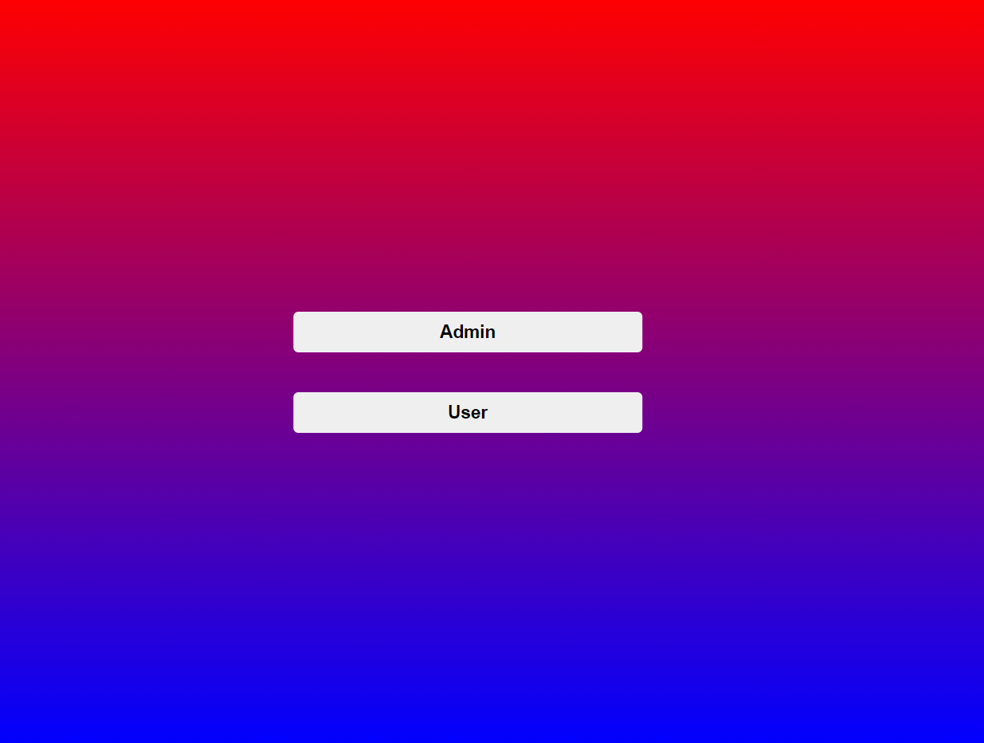

**Registration Form:**

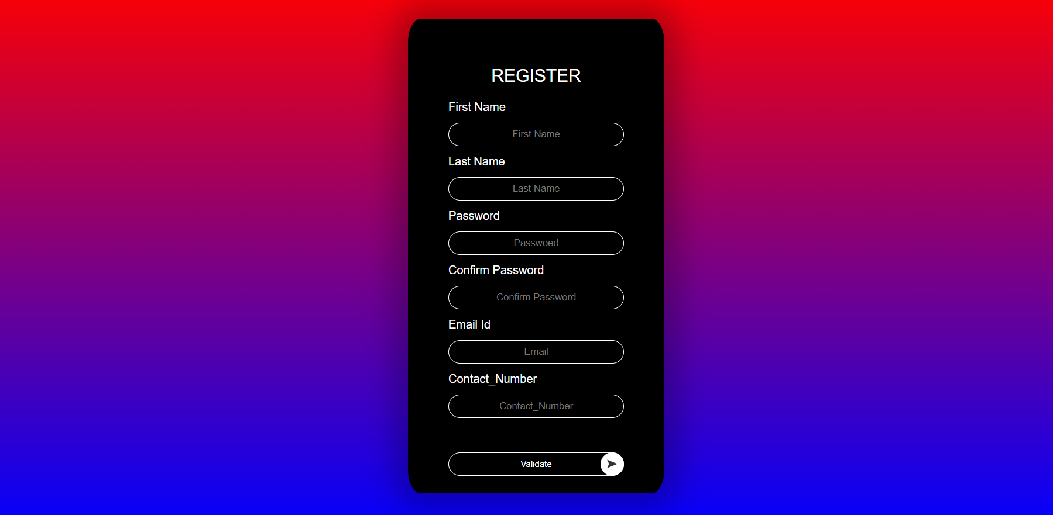

**User Registration Form:**

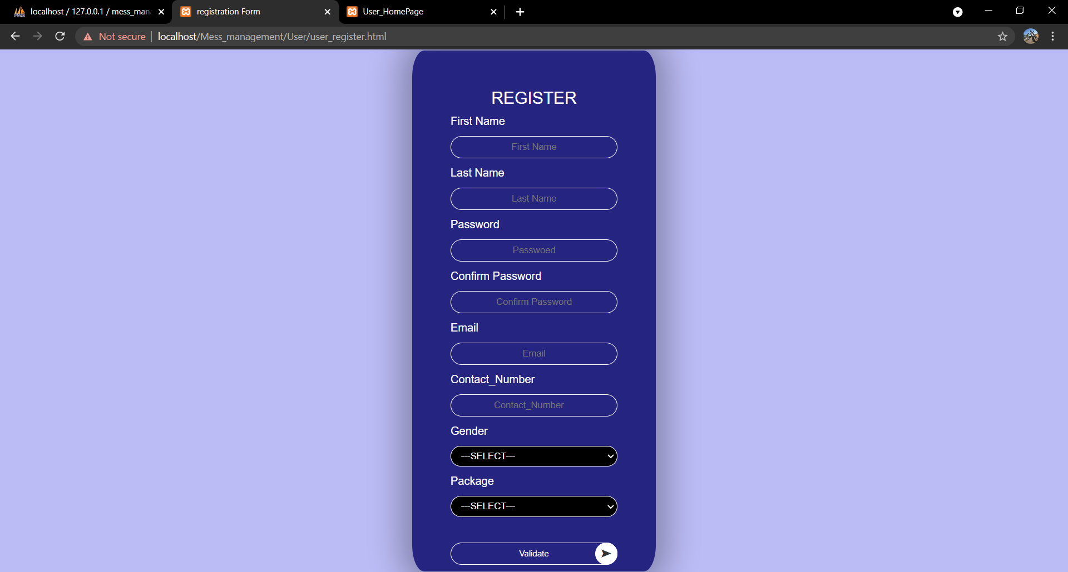

**Login Form: –**

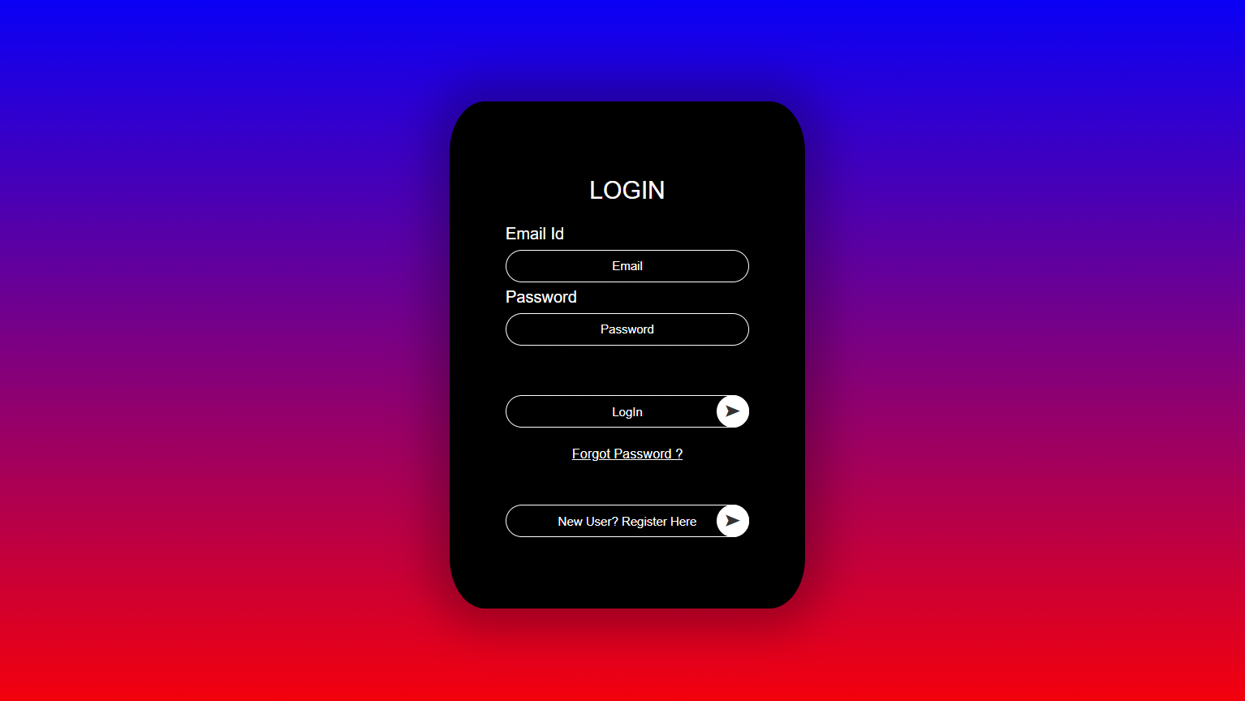

**Login successful:**

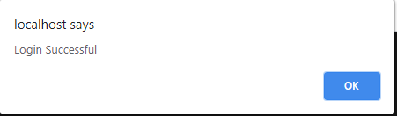

**Login Unsuccessful:**

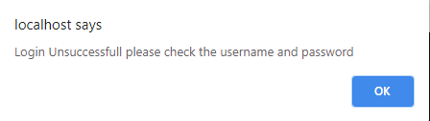

**Forgot Password:**

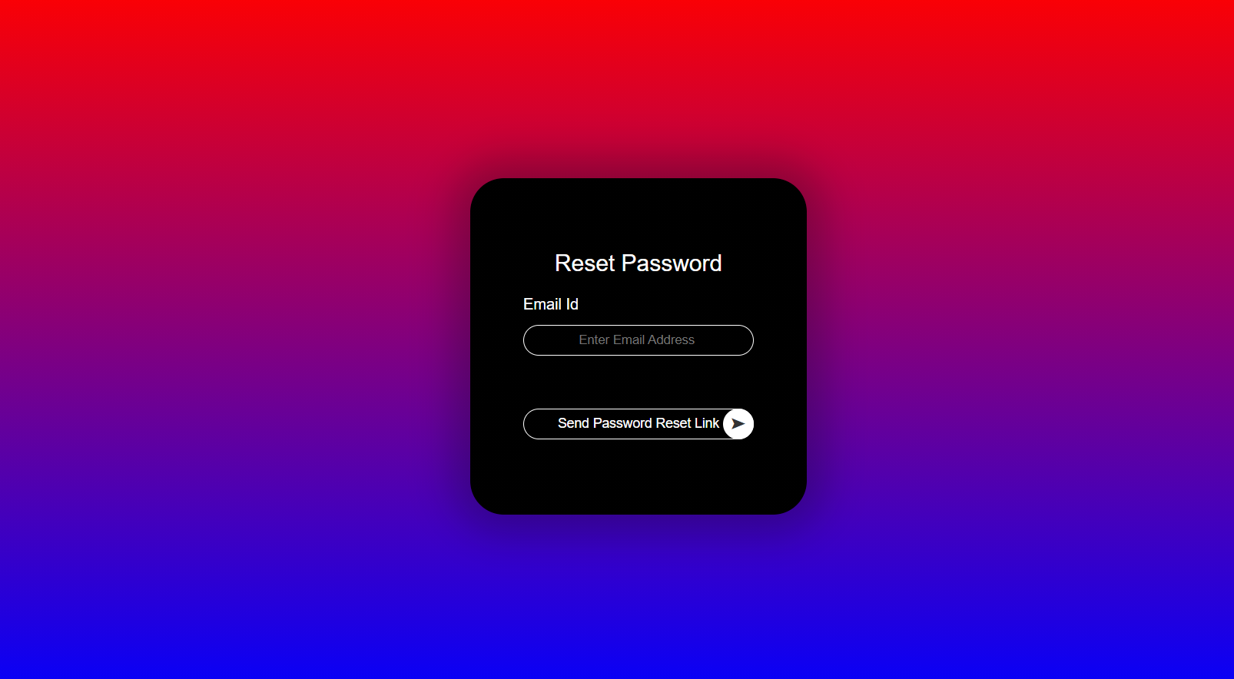

**Forgot Password Email Invalid:**

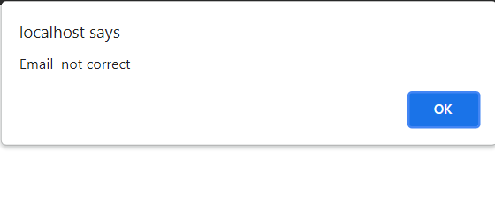

**Password recovery Mail:**

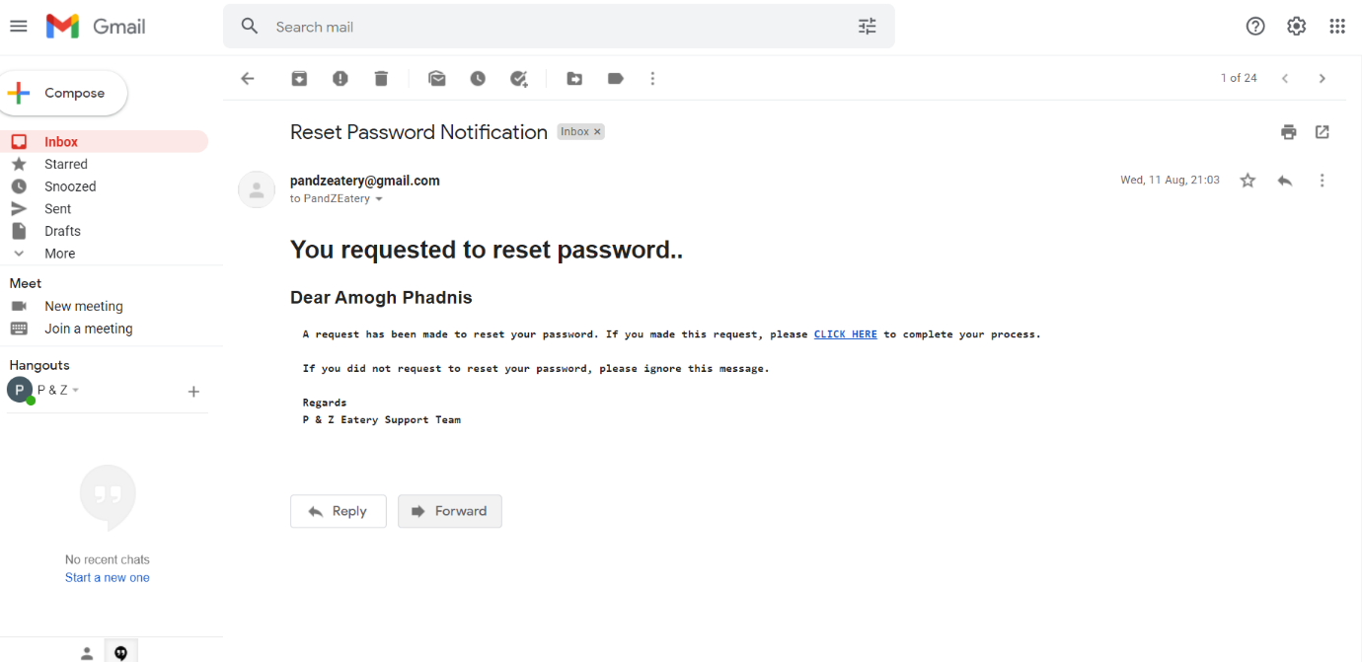

**Password Reset: -**

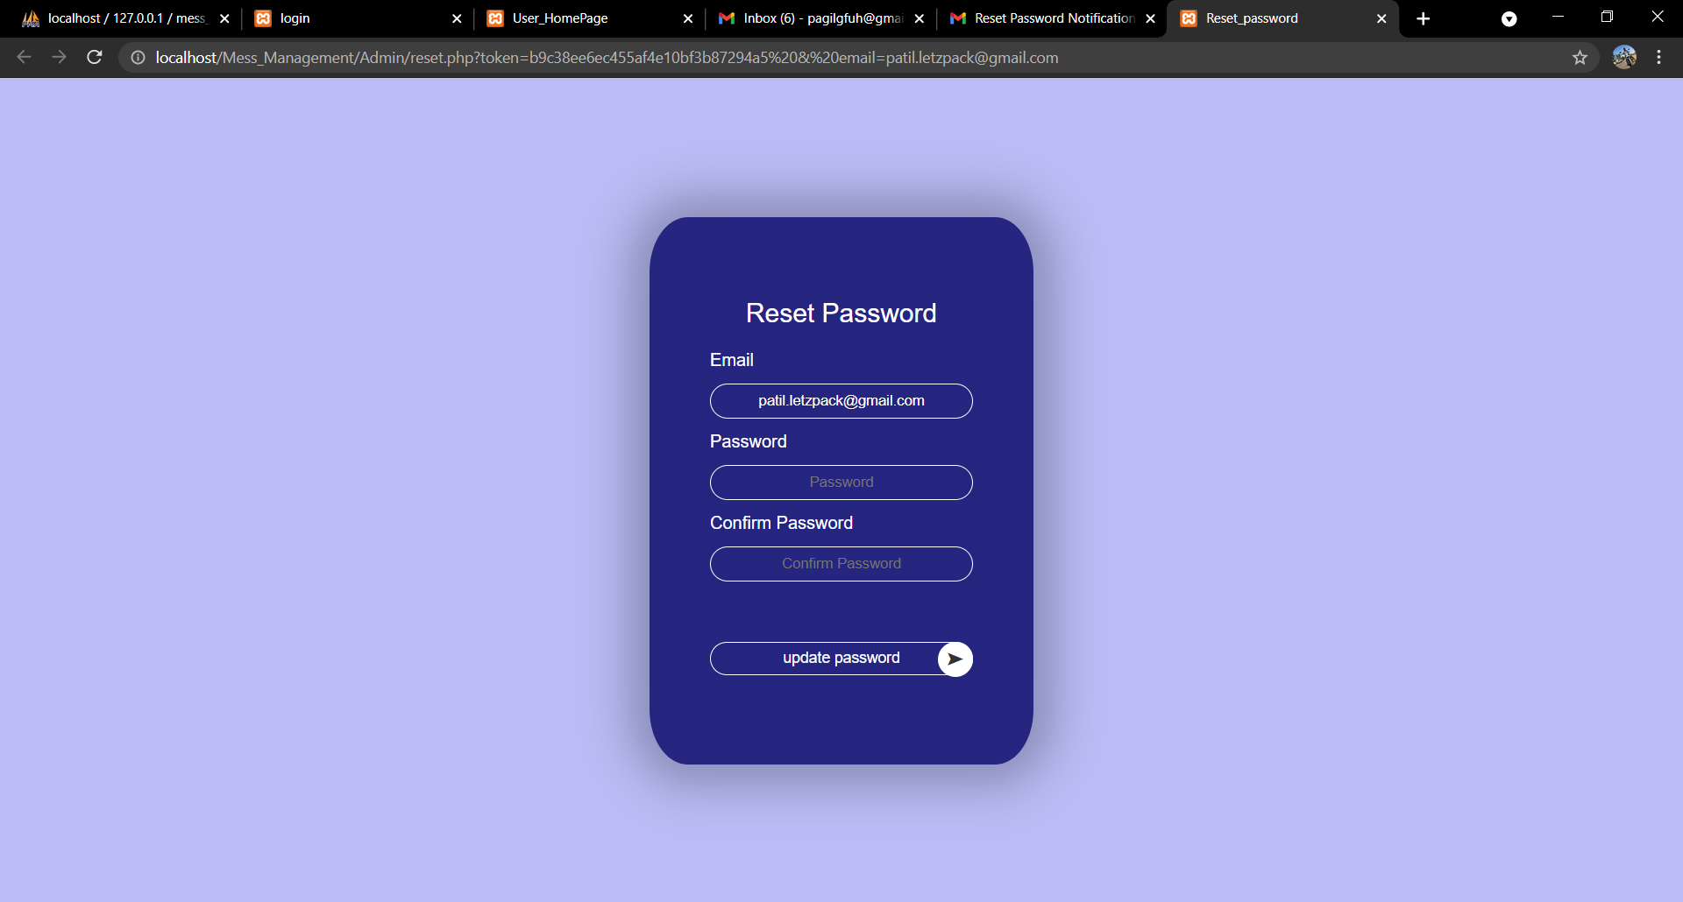

**Dashboard:**

**Admin Dashboard:**

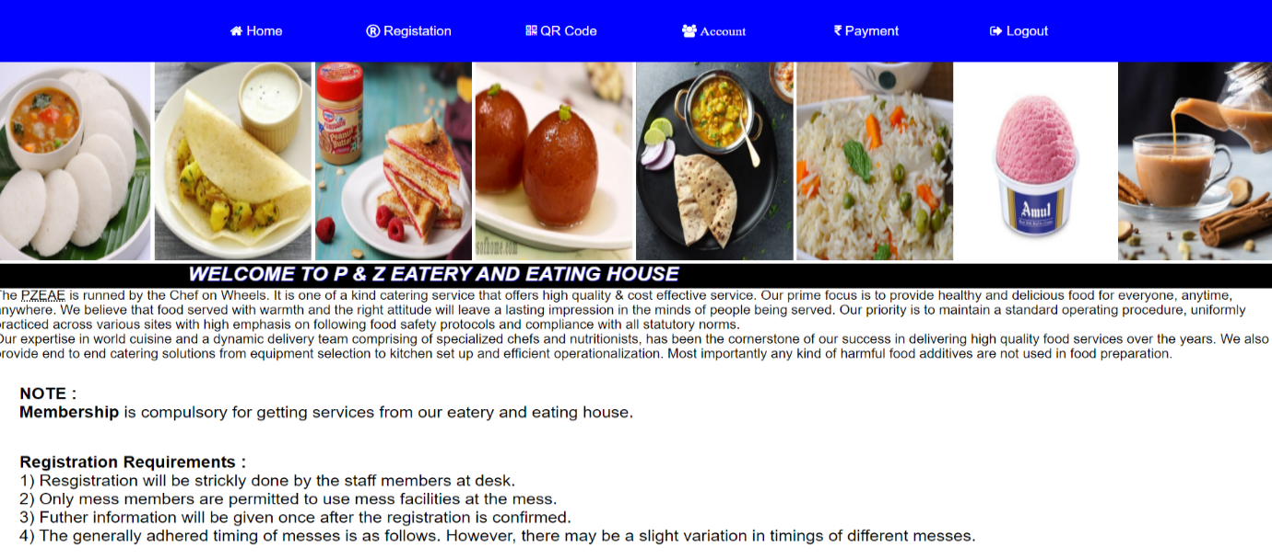

**User Details Editable records:**

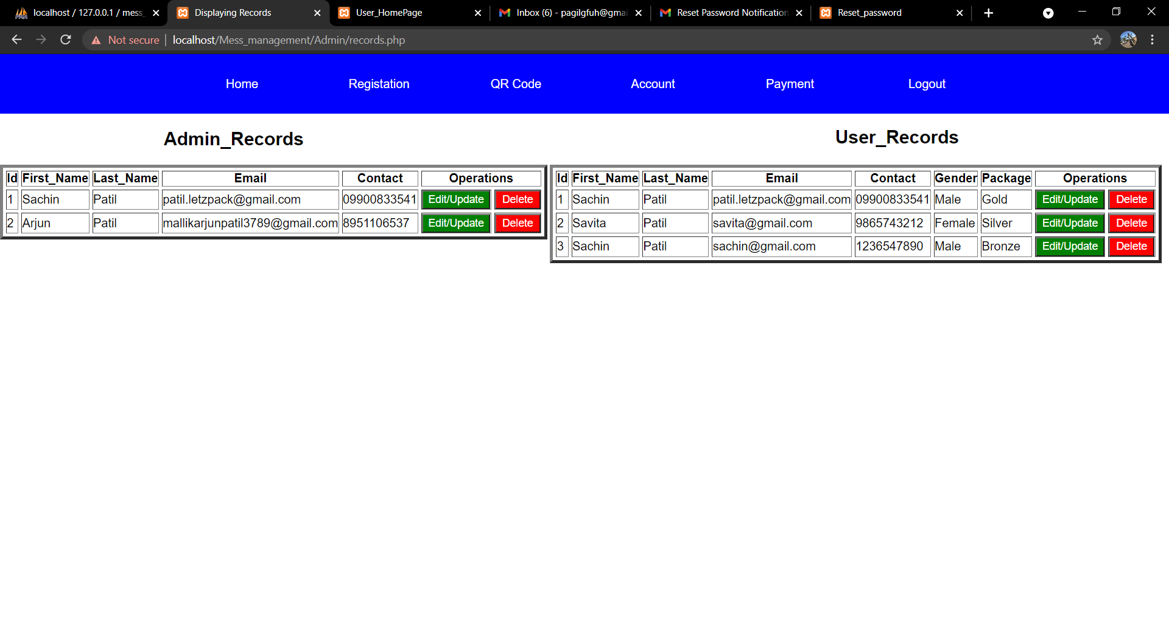

**QR code: -**

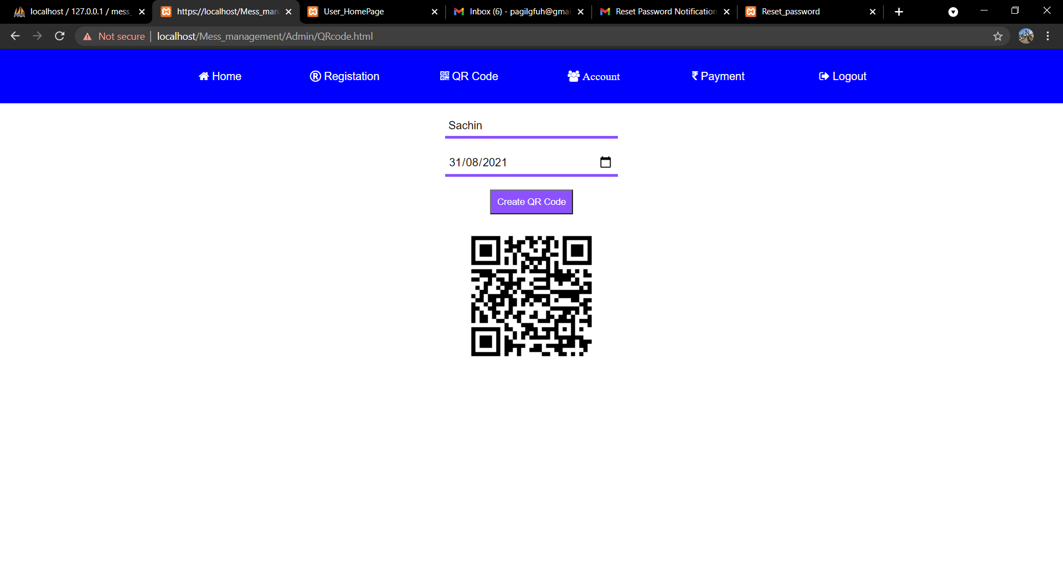

**User Dashboard:**

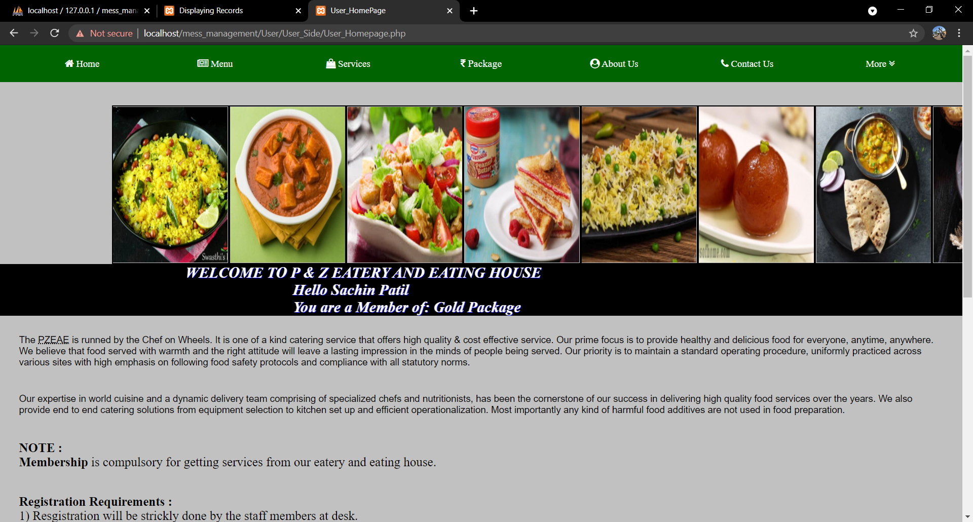

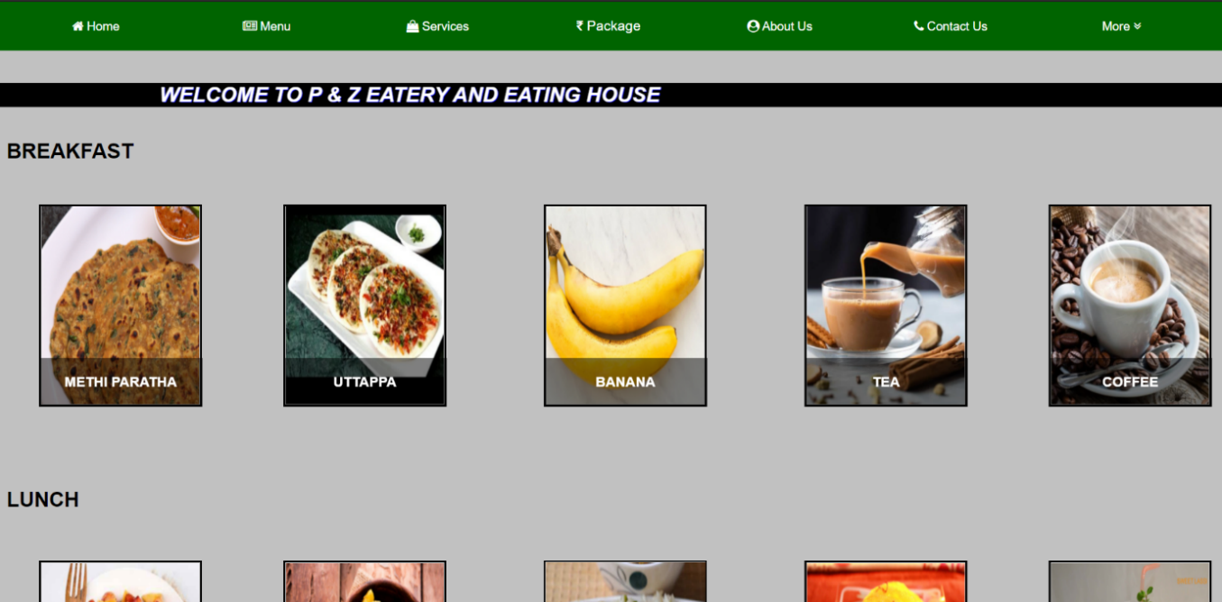

**Location:**

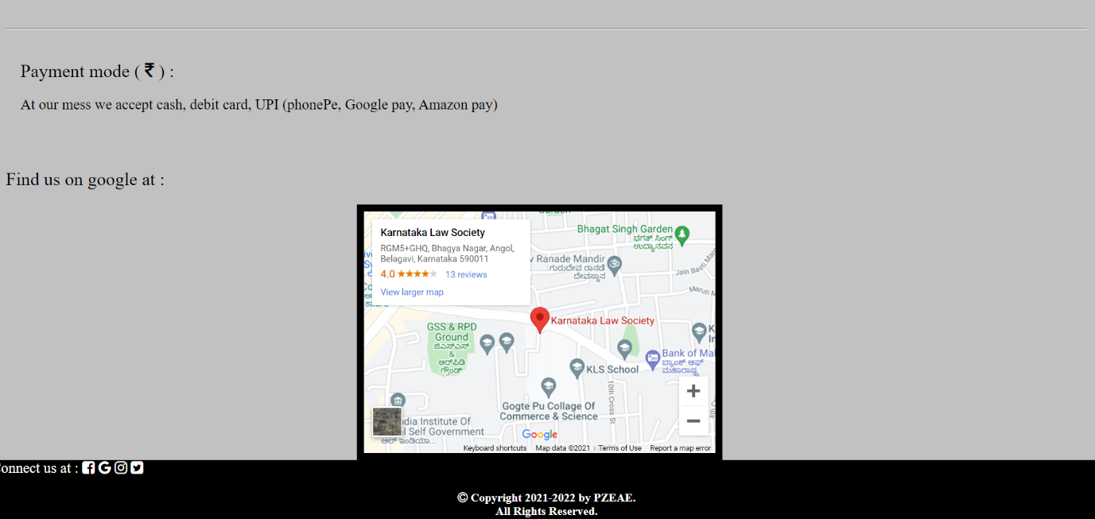

**Scanner: -**

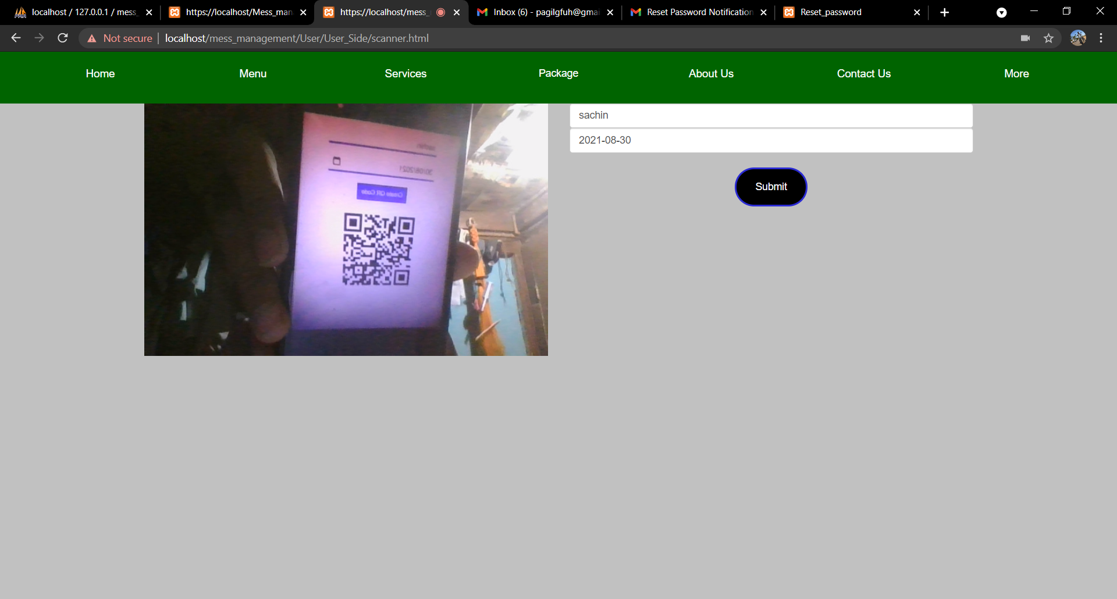

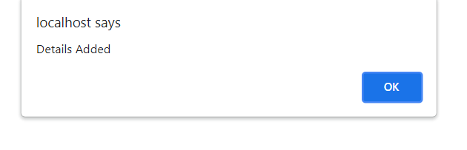

**ANNEXURE**

**MySQL Database:**

**Admin Database:**

|  |  |  |
| --- | --- | --- |
| **Name** | **Type** | **Size** |
| Id | Int (Primary key) | 11 |
| FName | Text | 255 |
| LName | Text | 255 |
| Pass | Text | 255 |
| Email | Text | 255 |
| Phone | Text | 255 |
| Token | Text | 255 |

**User Database:**

|  |  |  |
| --- | --- | --- |
| **Name** | **Type** | **Size** |
| Id | Int (Primary key) | 11 |
| FName | Text | 255 |
| LName | Text | 255 |
| Pass | Text | 255 |
| Email | Text | 255 |
| Phone | Text | 255 |
| Gender | Text | 255 |
| Package | Text | 255 |
| Token | Text | 255 |

**QR_Code Database:**

|  |  |  |
| --- | --- | --- |
| **Name** | **Type** | **Size** |
| Id | Int (Primary key) | 11 |
| name | Text | 255 |
| date | Text | 255 |

**CONCLUSION**

**Conclusion: -**

This framework proposes a common approach to facilitate the evaluation and monitoring of interventions to increase access to Mess Management in underserved areas. It suggests that a comprehensive approach needs to be used for the design, implementation, monitoring, evaluation, and review of such interventions. The framework is not intended to be prescriptive and can be applied flexibly to each context. Automatically reduces the work time. It does not require much time to check stock, book a vehicle, Vehicle information. And we can keep data for inventory turnover. This software will have seamless integration.

**REFERENCES**

1. YouTube references:-
   1. Cyber Warriors: -

<https://www.youtube.com/watch?v=2fM6BJXvP6A&t=0s>

* 1. Programming hub:- <https://www.youtube.com/channel/UCs6nmQViDpUw0nuIx9c_WvA>
  2. Code.org:- <https://www.youtube.com/channel/UCJyEBMU1xVP2be1-AoGS1BA>
  3. Manually update delete by admin:-

<https://www.youtube.com/watch?v=5W2qazb1-7c>

* 1. Mail service :-

<https://www.youtube.com/watch?v=Jyk5sBR6ksI>

<https://www.youtube.com/watch?v=IpznmyXApms>

1. Website references:-
   1. GeeksforGeeks:- <https://www.geeksforgeeks.org/>
   2. W3Schools:- <https://www.w3schools.com/>
   3. Tutorials Point:- <https://www.tutorialspoint.com/>
   4. PHP:- <https://www.php.net/>
   5. Xampp:- <https://www.apachefriends.org/index.html>

**FUTURE ENHANCEMENT**

Future Enhancement: -

* This project may be hosted as a website in upcoming future days.
* This project may include direct SMS system.